

**Software Engineering Project On**

**INTERNAL COMPLAINT MANAGEMENT SYSTEMS(CS311-P7)**

**Submission Date: 25/11/2019**

*Submitted to*

***Department of Computer Science & Engineering***

***IIIT BHAGALPUR, BIHAR 813210, INDIA***

**SUBMITTED BY**

**Group No.: CS311-170101003-P7**

**Group Leader’s Name: Abhishek Kumar(170101003)**

**Group Member’s Name: Himanshu Kumar(170101017)**

**Hitesh Kumar Sahu(170102019)**

**Suraj Kumar(170101052)**

**Under the Guidance of**

**Dr. Biswajit R. Bhowmik**

(CSE Dept.)

**Certificate**

This is to certify that the group of following students of 3rd year 5th semester in the Branch of Computer Science and Engineering has successfully completed a project entitled "**Internal Complaint Management System**" under the guidance of Dr. Biswajit R. Bhowmik during the academic year 2019-2020. The project had been prescribed towards automation of the existing system at the Institute and for consideration in partial fulfillment of the Software Engineering course curriculum of the Institute leading to the award of semester examination of July – December 2019.

The project work is originally carried out by them, a bona fide work of them, and may be considered as their mark of proficiency at the beginning level in Software Development.

**Project Members**

1. Abhishek Kumar (170101003), Team Leader
2. Himanshu Ranajn (170101017)
3. Suraj Kumar (170101052)
4. Hitesh Kumar Sahu (170102019)

|  |  |  |
| --- | --- | --- |
| Dr. Biswajit R. Bhowmik  Project Supervisor |  | Dr. Pradeep Kumar Biswal  Faculty-in-Charge |

TABLE OF CONTENT

1. INTRODUCTION 1

1.1 DOCUMENT SCOPE AND PURPOSE 1

1.2 TARGET AUDIENCE 1

2. REQUIREMENT ANALYSIS 2

2.1 SYSTEM REQUIREMENT 2

2.2 TOOLS REQUIREMENTS 2

2.2.1 PHP 2

2.2.2 HTML 2

2.2.3 CASCADING STYLE SHEETS 2

2.2.4 MySql 2

2.2.5 JAVA SCRIPT 3

3. DESIGN 4

3.1 DESIGN APPROACH 4

3.2 DESIGN PATTERNS 4

3.3 FLOW CHARTS 5

3.2.1 ICMS Home 5

3.2.2 Admin 6

3.2.3.Student Login/Registrations and Raise Complaint 7

3.2.4 Faculty/Staff Login/Registrations and Raise Complaint 8

3.2.5 Others Login/Registrations and Raise Complaint 9

3.2.6 Student Affairs Board 10

3.2.7. Faculty Affairs Board 11

4. IMPLEMENATION 12

4.1 DATA DICTIONARY 12

4.2 SNAPSHOTS 16

4.2.1 Home 16

4.4.2 Admin 18

4.2.3 Student 22

4.2.4 Faculty and Staff 26

4.2.5 Outsider’s 29

4.2.6 Student Affairs Board 32

4.2.7 Faculty Affairs Board 36

4.2.8 Emails 39

5. TESTING 41

5.1 TESTING GOAL 41

5.2 FUNCTIONAL REQUIREMENTS TESTING (BLACK BOX TESTING) 41

**5.2.1** Registration for New User 41

**5.2.2** Raised Complaint by Student / Faculty/ Staff/ Outsider 42

**5.2.3** Processing Complaint by Student Affairs Board / Faculty Affairs Board 43

**5.2.4** Admin Activities 44

5.3 Non- Functional Requirements Testing 45

5.3.1 Stability Testing 45

5.3.2 Usability 45

5.3.3 Security Testing 45

6. MAINTAINENCE 46

7. CONCLUSION 47

# 1. INTRODUCTION

In the existing paper work related to internal complaint management, complaints are maintained using the file or register. The complainant needs to submit their complaint manually to their respective authorities. This increases the paperwork & maintaining the records becomes tedious. Maintaining complaint details in the records also increases the paperwork. The main objective of the proposed system is to decrease the paperwork and help in easier record maintenance by having a centralized Database System, where Complaint and Solutions are maintained. The proposed system automates the existing system. It decreases the paperwork and enables easier record maintenance. It also reduces chances of Data loss.

## 1.1 DOCUMENT SCOPE AND PURPOSE

This document provides a description of the technical design for Internal Complaint Management System of **Indian Institute of Information Technology Bhagalpur**. This document provides an architectural overview of the system to depict different aspects of the system. This document also functions as a foundational reference point for developers.

## 1.2 TARGET AUDIENCE

This document is targeted (but not limited) to technical stakeholders:

* Development Team
* Clients
* Respective Authority

It is assumed that the reader has a technical background in software design and development.

# 2. REQUIREMENT ANALYSIS

## 2.1 SYSTEM REQUIREMENT

* Development: PHP+ HTML + CSS + JavaScript
* Unit Test: unit test(localhost)
* Diagrams: Lucid Chart
* Database Management: phpmyadmin
* Database: MySQL
* Server: Apache Server
* Discussion: Normal Group Discussion

## 2.2 TOOLS REQUIREMENTS

### 2.2.1 PHP

Originally stood for personal homepage currently, it is known as hypertext preprocessor widely used as a general purpose server-side scripting language that was originally designed for developing dynamic web pages.

### 2.2.2 HTML

(Hypertext markup language) is the set of markup symbols or codes inserted in a file intended for display on a World Wide Web browser page.

### 2.2.3 CASCADING STYLE SHEETS

CSS is a style sheet language used for describing the presentation of a document written in a markup language.css is a cornerstone technology used by most websites to create visually engaging webpages, user interfaces for web applications.

### 2.2.4 MySql

It is English like database query language used for retrieving and managing data in a relational database management system, it is a query language for querying and modifying data and managing databases.

### 2.2.5 JAVA SCRIPT

 JS is an object-oriented computer programming language commonly used to create interactive effects within web browsers. In script languages it is easier and faster to code in than the more structured and complied languages such as C and C++…

# 3. DESIGN

## 3.1 DESIGN APPROACH

The design approach used here is based on the following:

1. DATA FLOW DESIGN: The data flow of the Internal Complaint Management System is Internet-based.
2. ARCHITECHTURE DESIGN: The Internal Complaint Management System is developed with the help of PHP, SMTPLib, PHPMailerLib and FPDFLib. The database used is MySQL, and the web application is deployed through XAMPP Server.
3. UI DESIGN: The Internal Complaint Management System uses HTML, CSS and JavaScript at the Front End. It has been made such that the web application is very user friendly and all the functions present will make the life of user easier.

## 3.2 DESIGN PATTERNS

This application is designed as an object-oriented system for an Internet-based architecture by factoring application classes into the following layers:

1. The Presentation layer: This is the layer where the physical window and widget objects live. Any new user interface widgets developed for this application are put in this layer.
2. THE DOMAIN MODE: Most objects identified in the OO analysis and design will reside. To a great extent, the objects in this layer can be application-independent. Generic objects may be used in this application to reap the benefits of Object Oriented programming.
3. THE DATA LAYER: The data is managed by MySQL.

## 3.3 FLOW CHARTS

### 3.2.1 ICMS Home

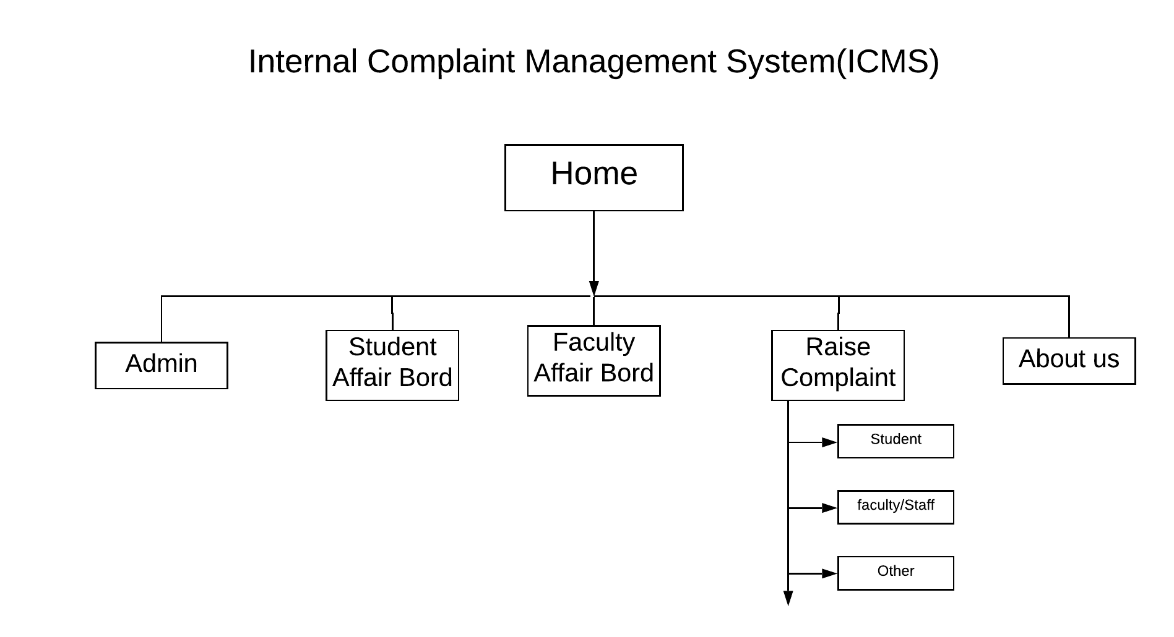

### 3.2.2 Admin

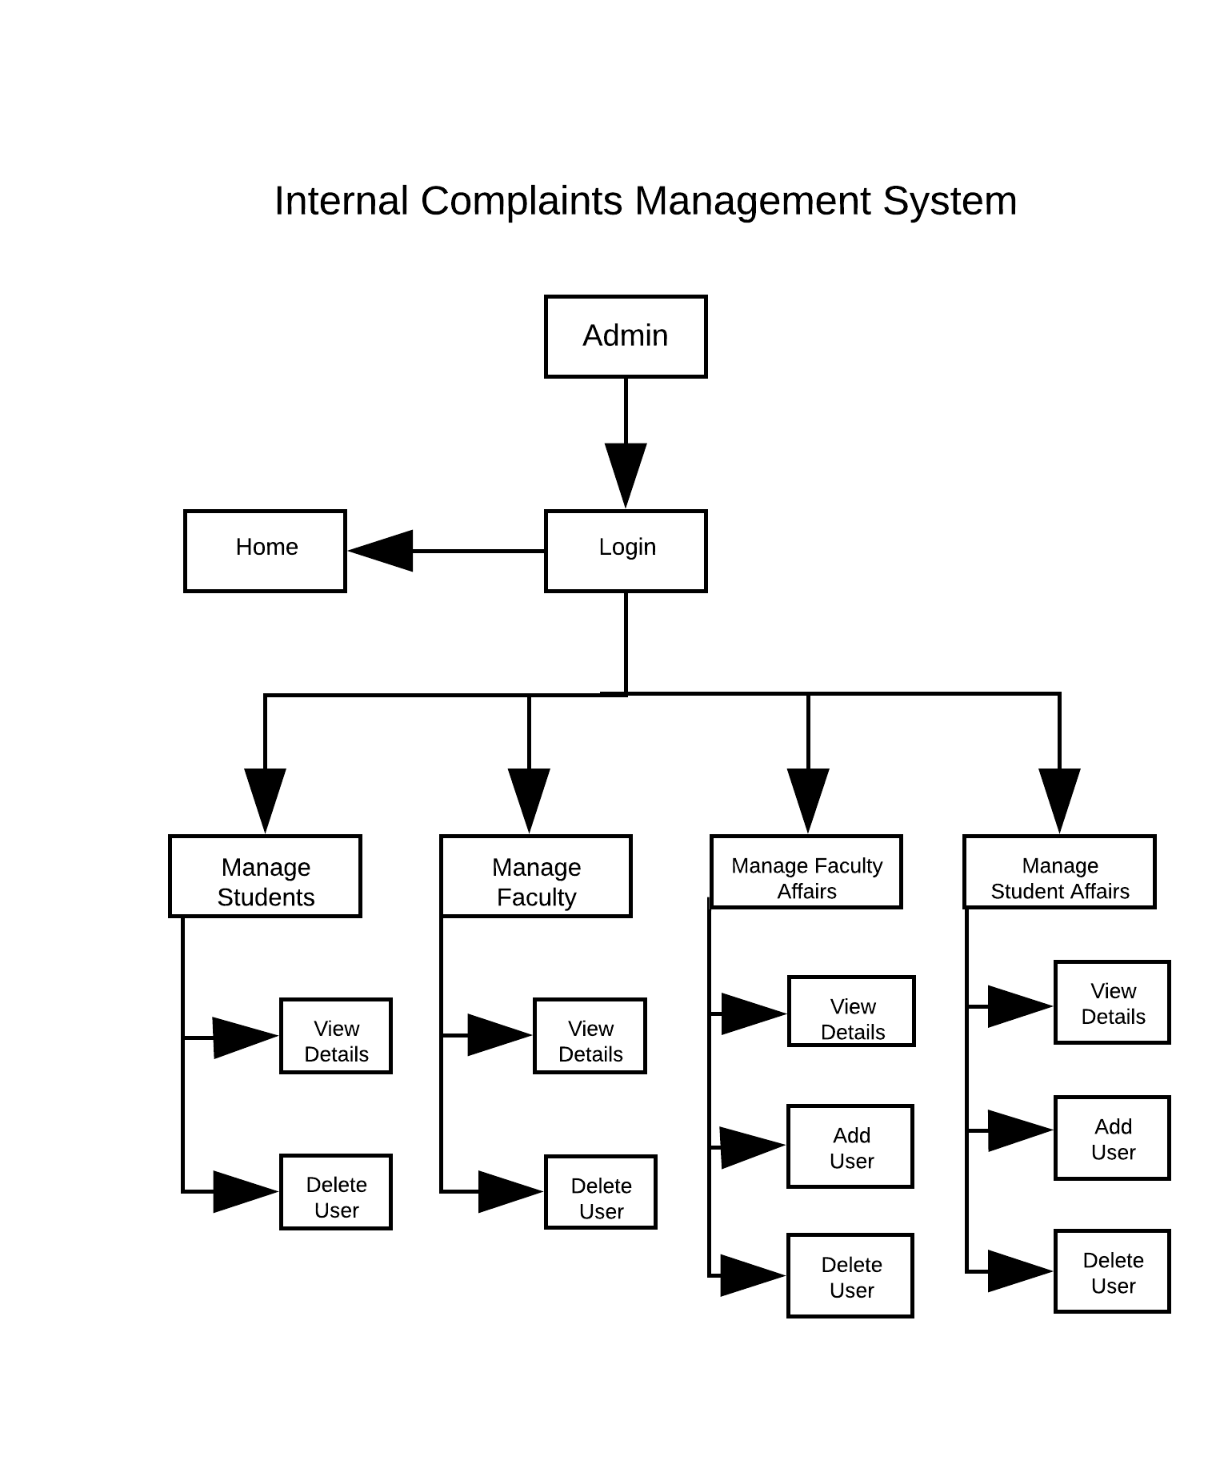

### 3.2.3.Student Login/Registrations and Raise Complaint

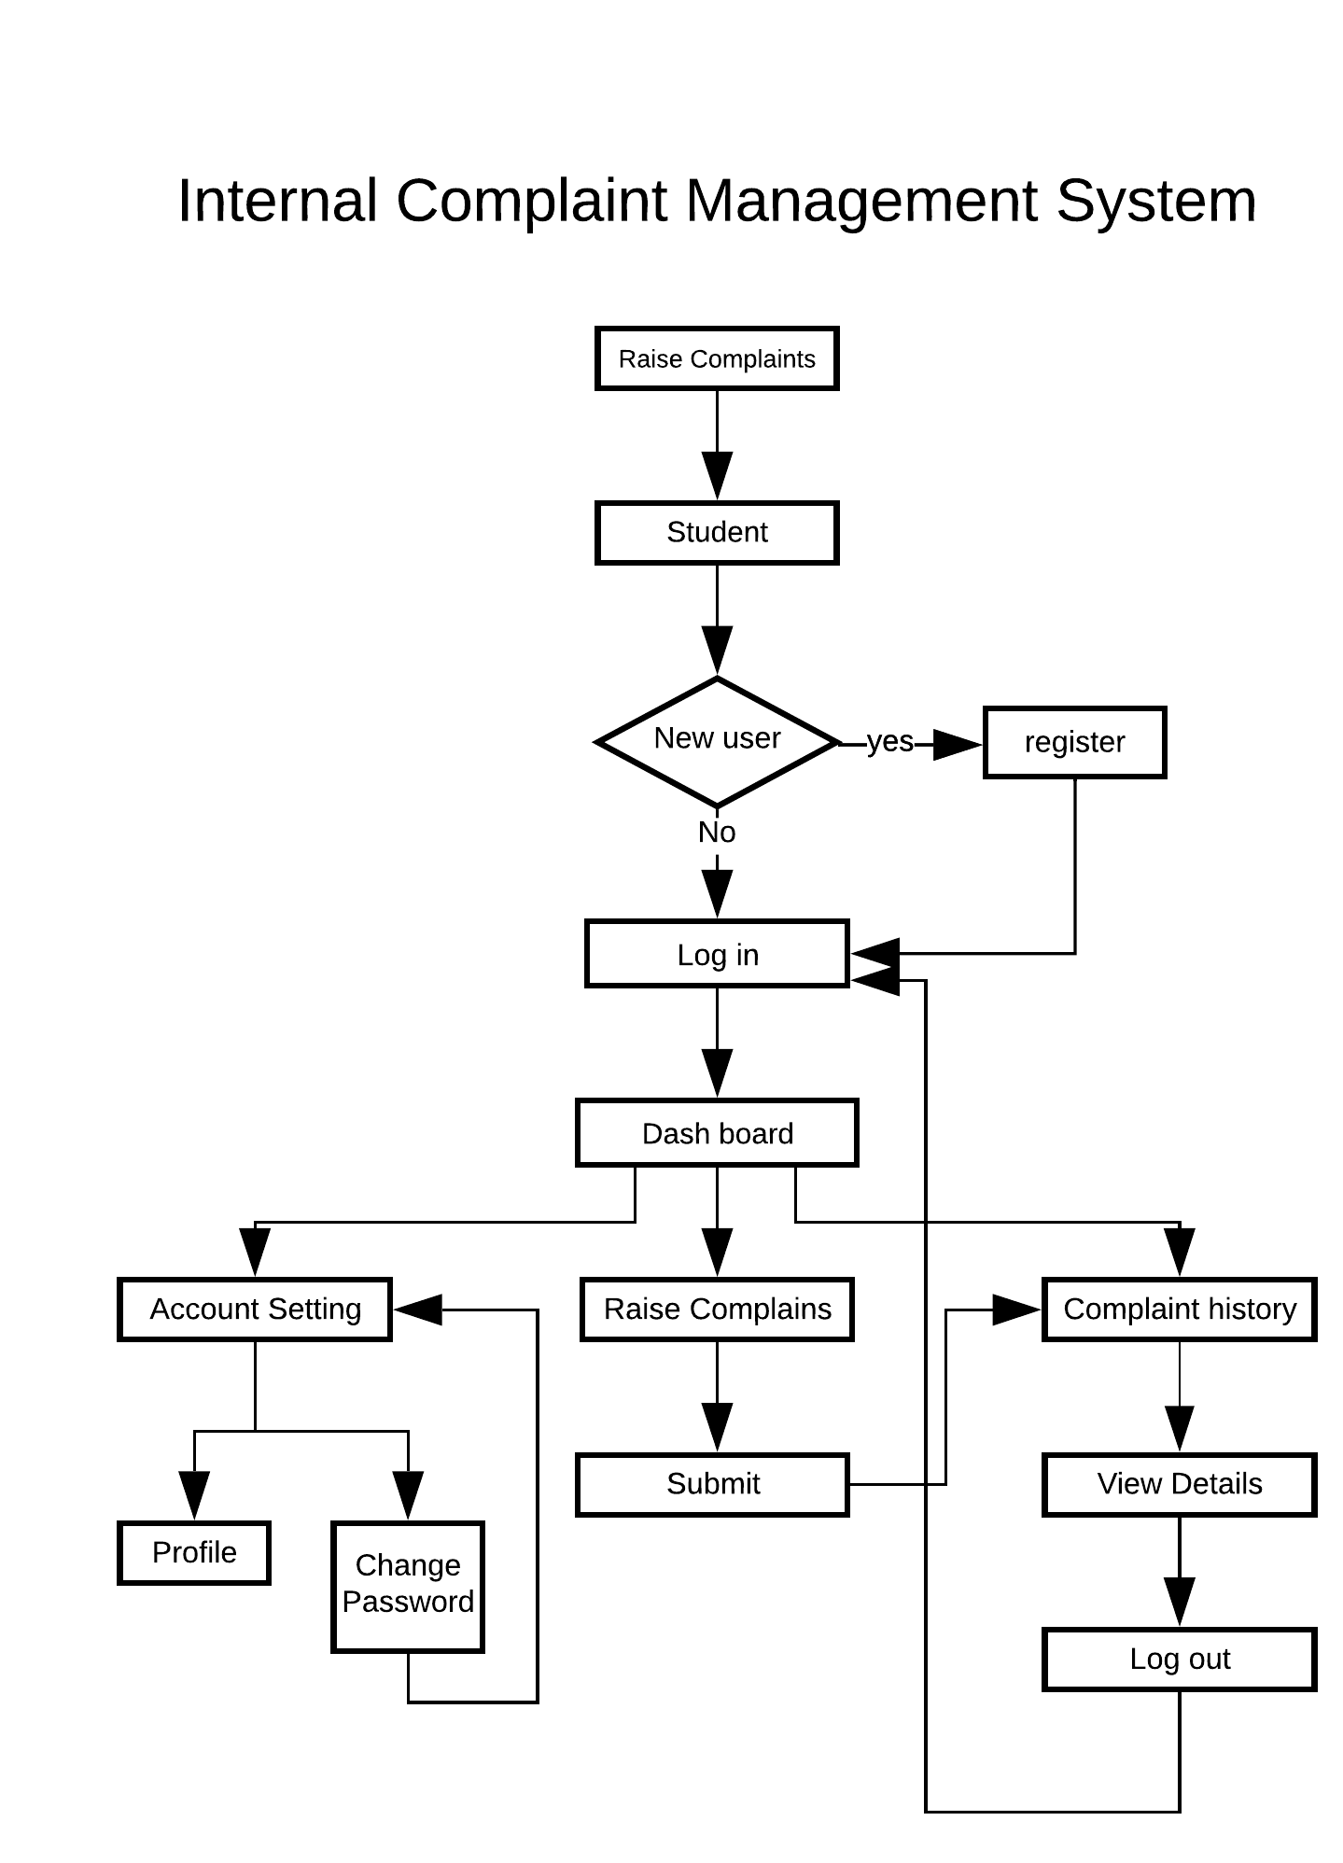

### 3.2.4 Faculty/Staff Login/Registrations and Raise Complaint

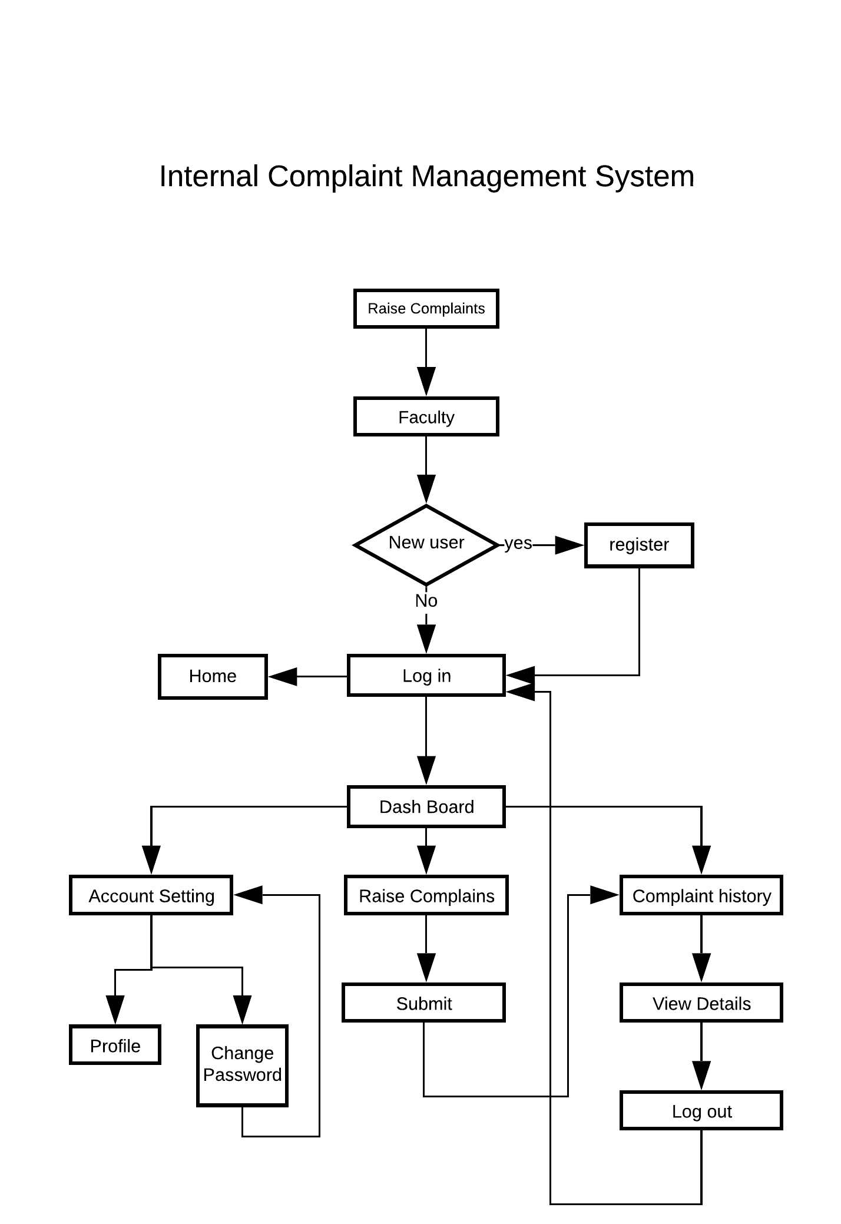

### 3.2.5 Others Login/Registrations and Raise Complaint

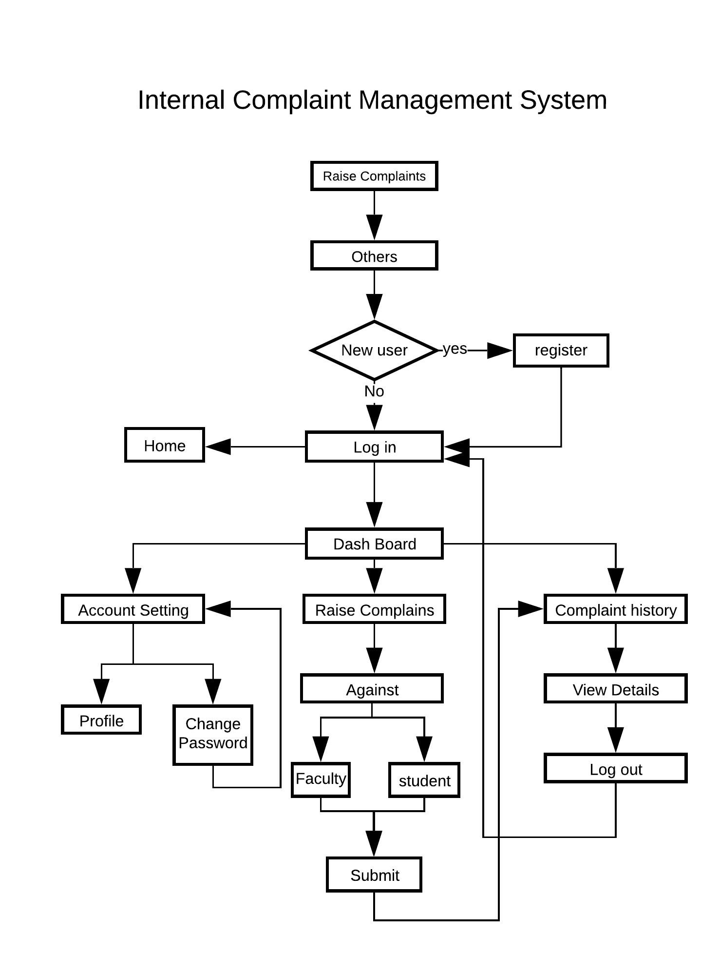

### 3.2.6 Student Affairs Board

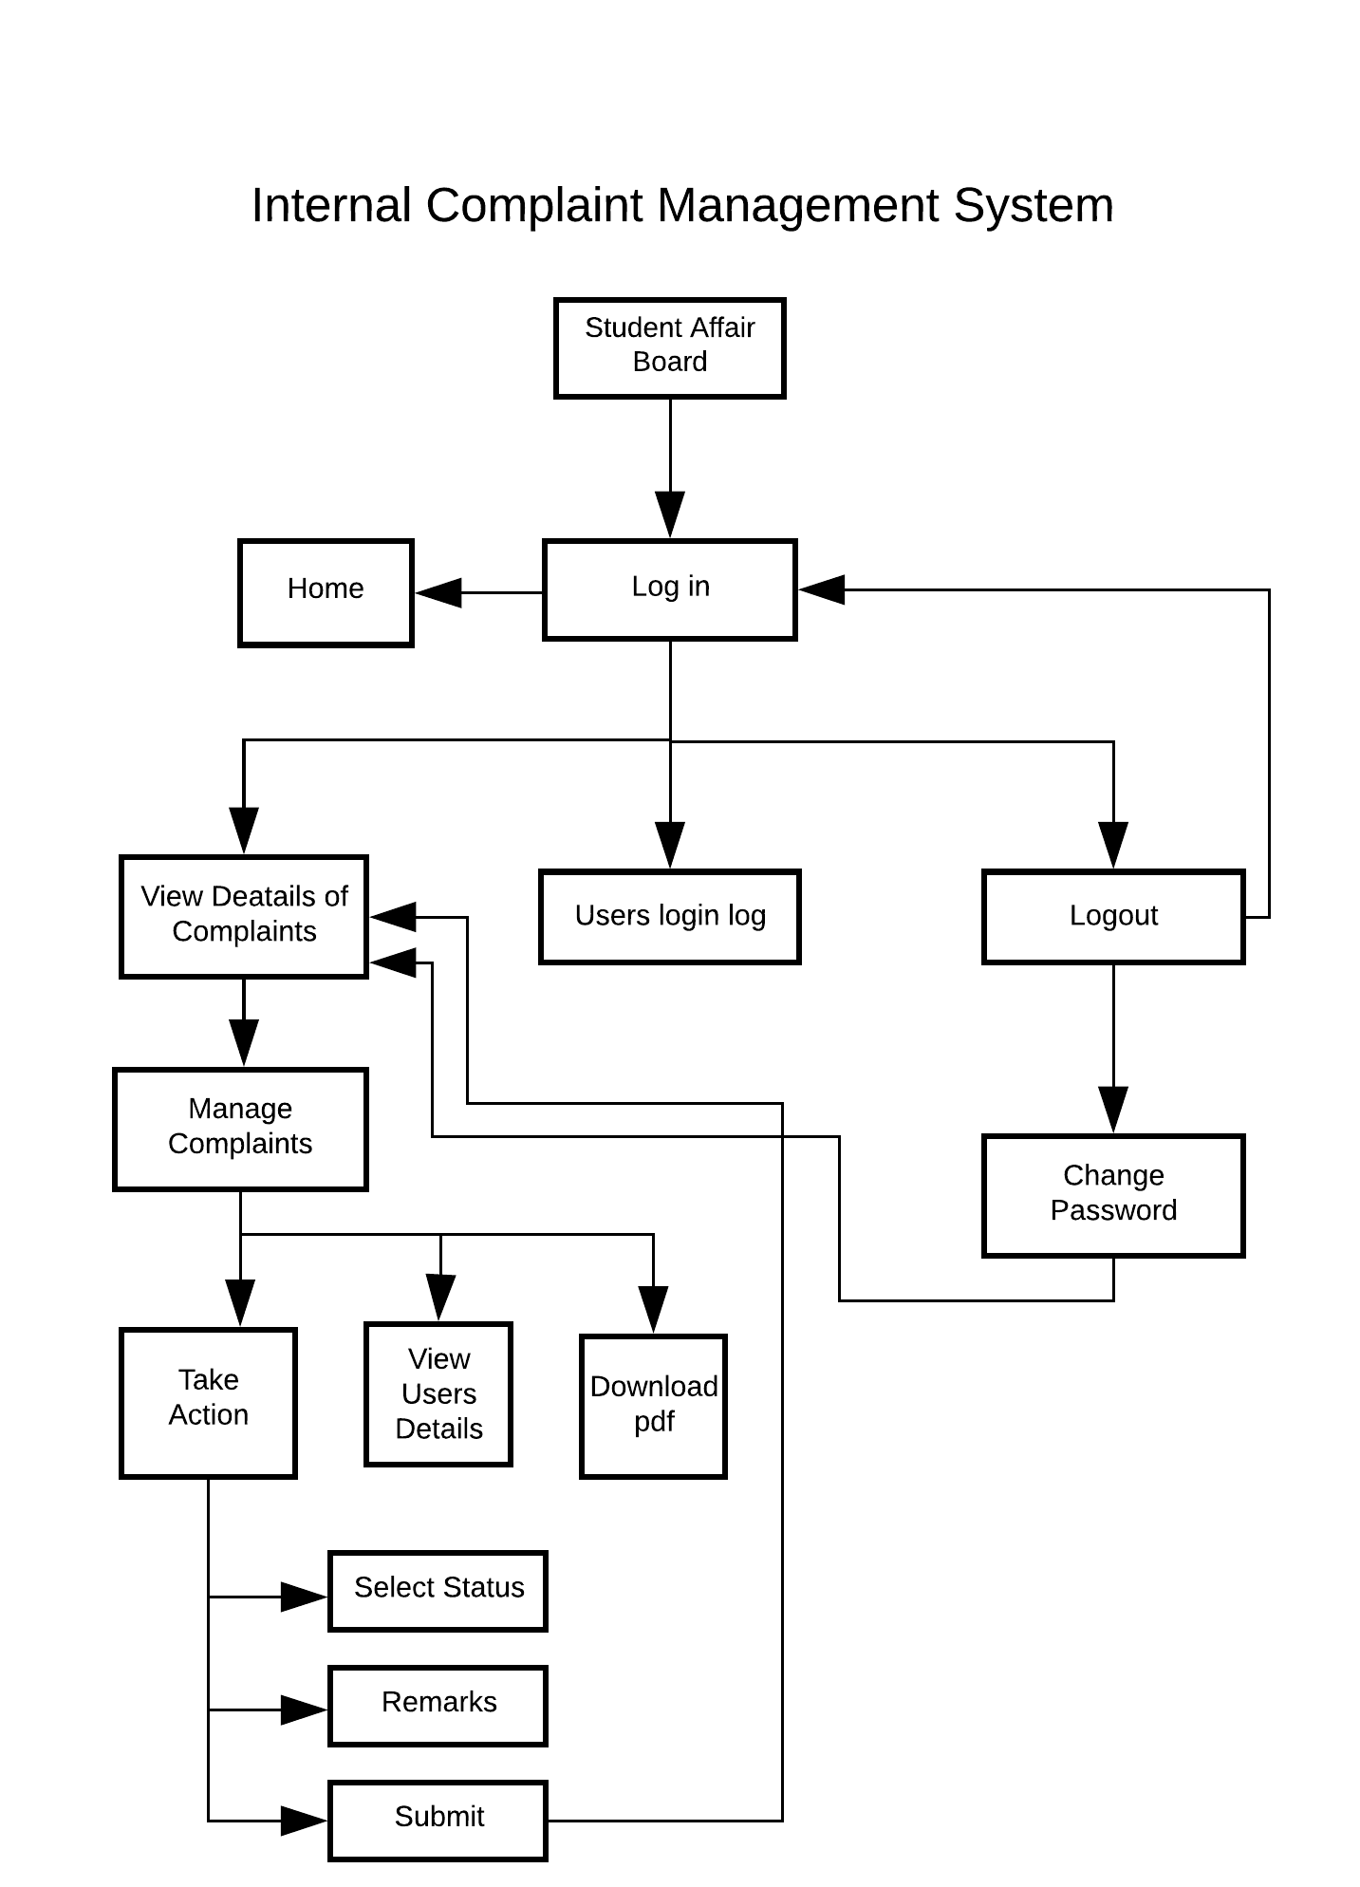

### 3.2.7. Faculty Affairs Board

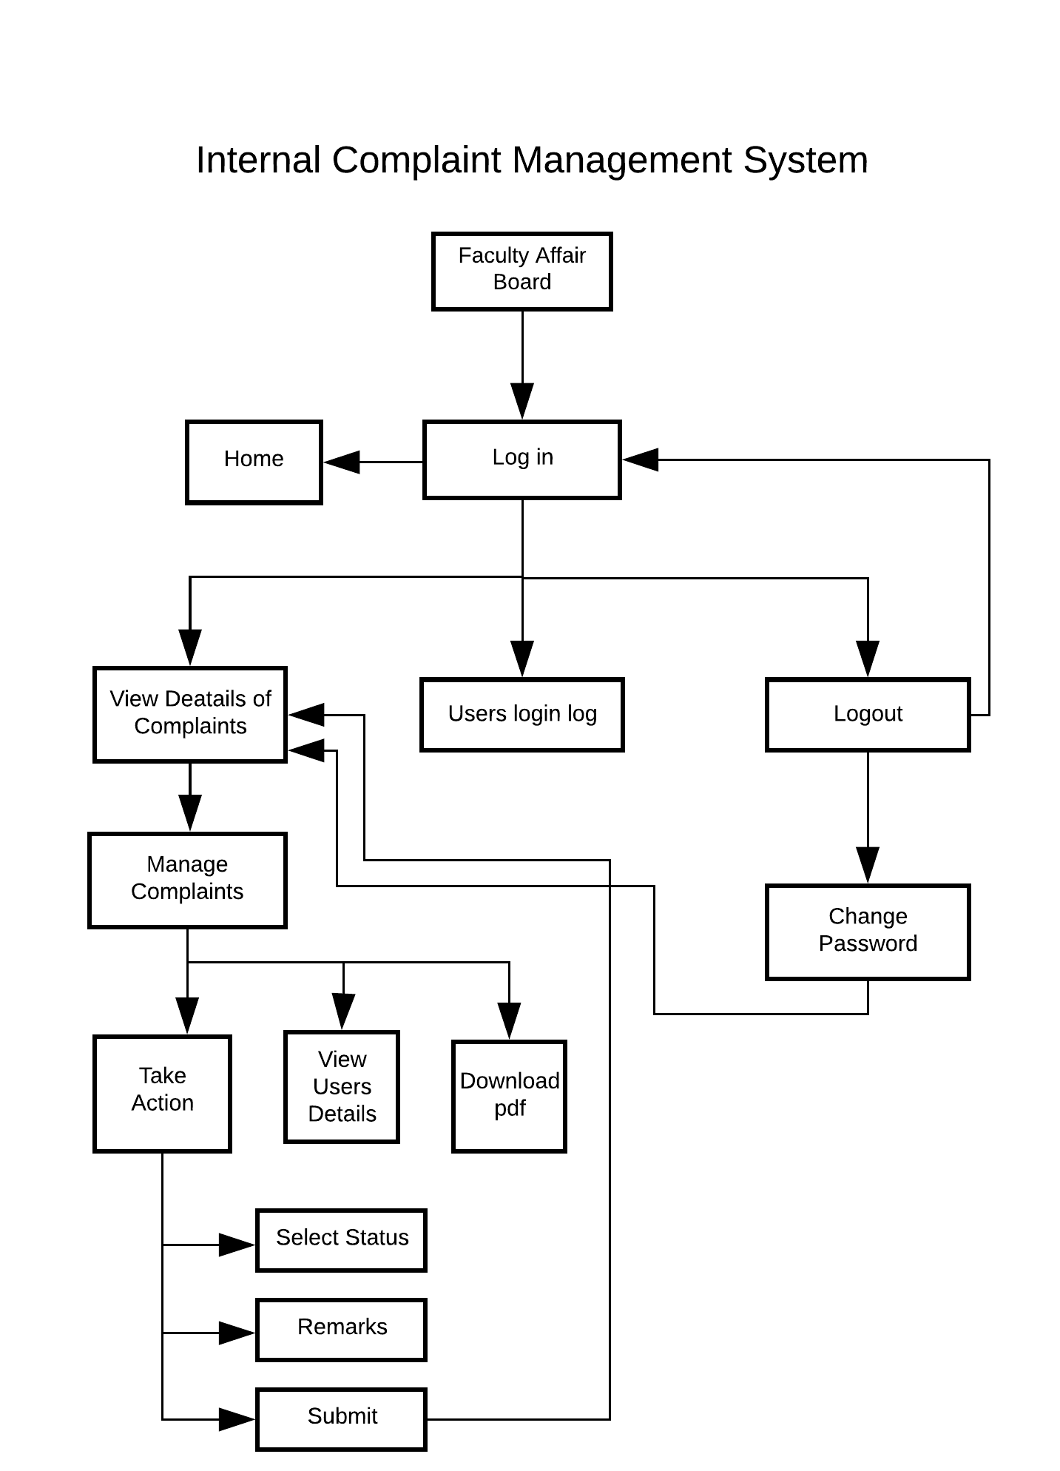

# 4. IMPLEMENATION

## 4.1 DATA DICTIONARY

|  |  |  |
| --- | --- | --- |
| admin | id | integer *Auto Increment* |
| username | text |
| password | character varying |
| updationDate | Varchar(255) current_timestamp() |
|  |  |  |
| facstaff | id | integer |
| full Name | Varchar(225) |
| empEmail | Varchar(225) |
| password | Varchar(225) |
| dept | Varchar(255) |
| contactNo | Bigint (11) |
| empimage | Varchar(225) |
| regDate | timestamp |
| updationDate | timestamp |
| status | Int(1) |
|  |  |  |
| facstaffaffairs | id | Int(11) |
| name | Varchar(225) |
| usename | Varchar(225) |
| password | Varchar(225) |
| contactNo | Bigint(11) |
| updationDate | Varchar(225) |
|  |  |  |
| facstaffcatogary | id | Int(11) |
| catogaryName | Varchar(225) |
| catogaryDescription | Varchar(225) |
| creationDate | timestamp |
| updationDate | timestamp |
|  |  |  |
| facstaffcomplaintsremark | Id | Int(11) |
| complaintNo | Int(11) |
| status | varchar(225) |
| remark | Mediumtext |
| remarkDate | Timestamp |
|  |  |  |
| Facstafftblcomplaints | complaintNo | Int(11) |
| userId | Varchar(20) |
| Catogary | Vatchar(20) |
| Noc | Varchar(220) |
| complaintDetails | Varchar(2000) |
| complaintFile | Vatchar(225) |
| regDate | Timestamp |
| Status | Varchar(50) |
| lastUpdationDate | Timestamp |
|  |  |  |
| others | id | integer |
| full Name | Varchar(225) |
| email | Varchar(225) |
| password | Varchar(225) |
| Occupation | Varchar() |
| contactNo | Bigint (11) |
| image | Varchar(225) |
| regDate | timestamp |
| updationDate | timestamp |
| status | Int(1) |
|  |  |  |
| Otp_expiry | id | Int(11) |
| otp | Int(6) |
| Create_at | Timestamp |
| Is_expired | Int(1) |
| email | Varchar(225) |
|  |  |  |
| stud | id | integer |
| full Name | Varchar(225) |
| studEmail | Varchar(225) |
| password | Varchar(225) |
| Branch | Varchar() |
| contactNo | Bigint (11) |
| studimage | Varchar(225) |
| regDate | timestamp |
| updationDate | timestamp |
| status | Int(1) |
|  |  |  |
| studaffaffairs | id | Int(11) |
| name | Varchar(225) |
| usename | Varchar(225) |
| password | Varchar(225) |
| contactNo | Bigint(11) |
| updationDate | Varchar(225) |
|  |  |  |
| studcategory | id | Int(11) |
| categoryName | Varchar(225) |
| categoryDescription | Varchar(225) |
| creationDate | timestamp |
| updationDate | timestamp |
|  |  |  |
| studcomplaintsremark | Id | Int(11) |
| complaintNo | Int(11) |
| Status | varchar(225) |
| Remark | Mediumtext |
| remarkDate | Timestamp |
|  |  |  |
| studtblcomplaints | complaintNo | Int(11) |
| userId | Varchar(20) |
| Catogary | Vatchar(20) |
| Noc | Varchar(220) |
| complaintDetails | Varchar(2000) |
| complaintFile | Vatchar(225) |
| regDate | Timestamp |
| Status | Varchar(50) |
| lastUpdationDate | Timestamp |
|  |  |  |
| uselog | id | integer |
| uid | Varchar(225) |
| usename | Varchar(225) |
| userip | Varchar(225) |
| loginTime | timestamp |
| logout | varchar (225) |
| Status | Int(1) |

## 4.2 SNAPSHOTS

### 4.2.1 Home

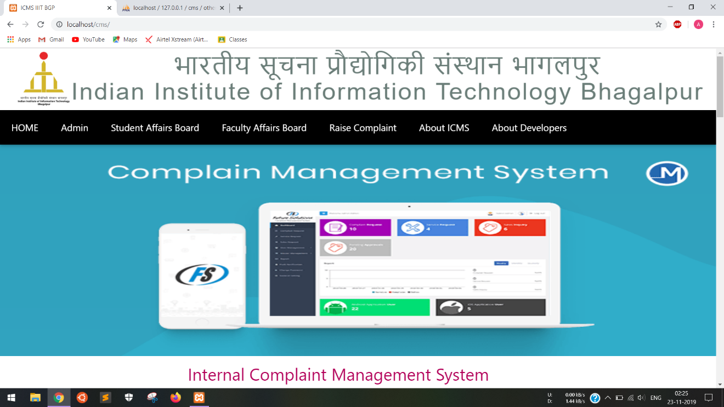

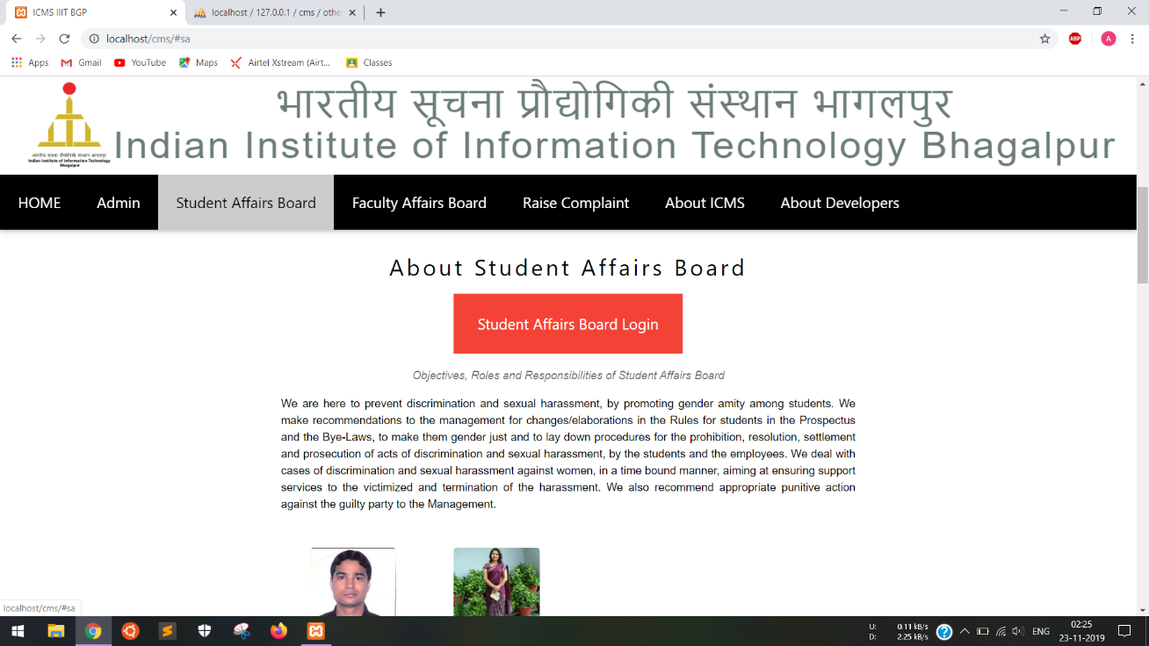

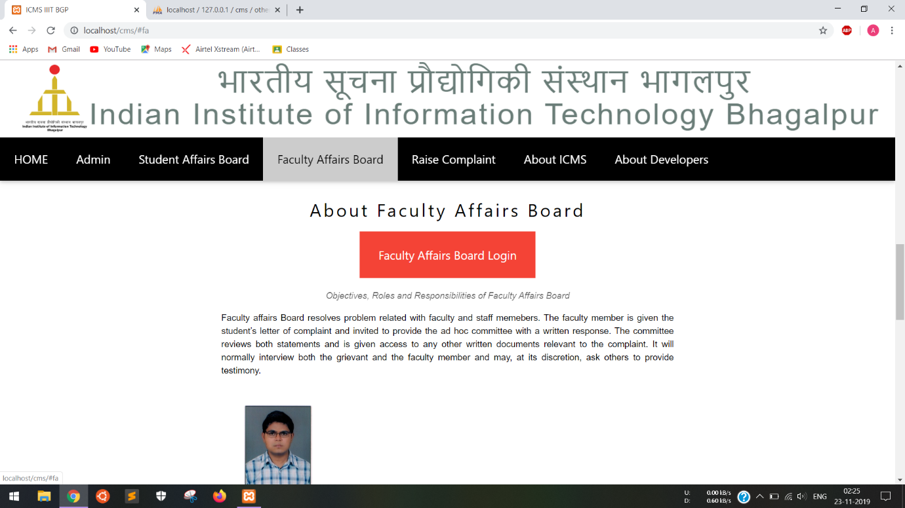

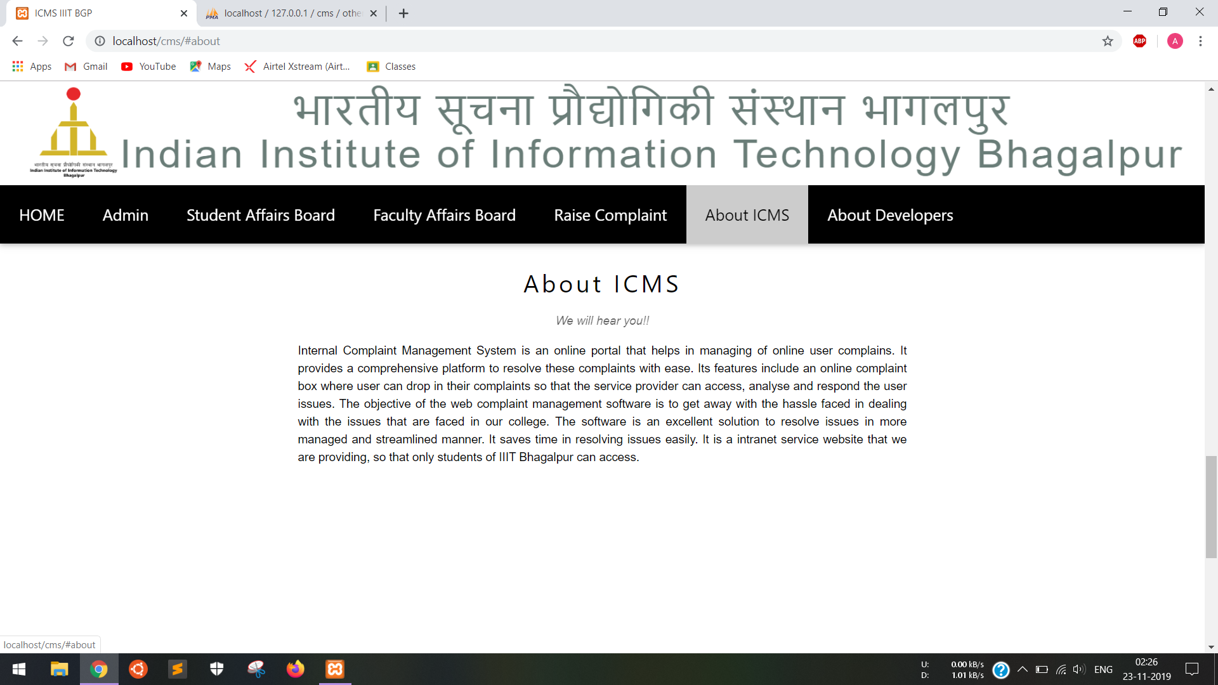

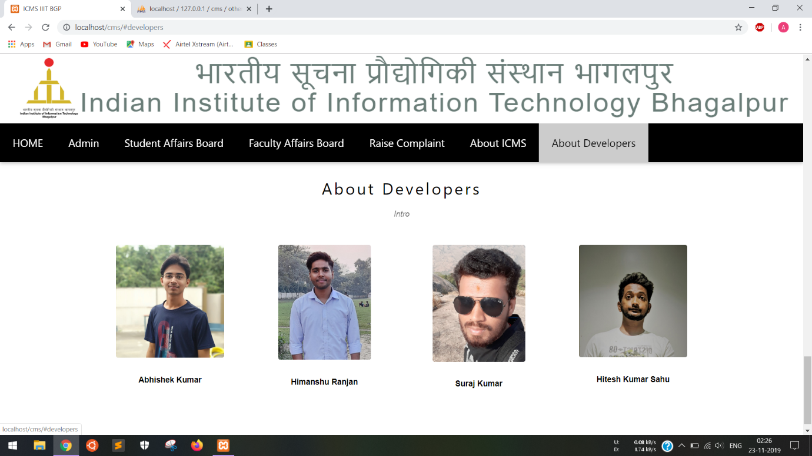

### 4.4.2 Admin

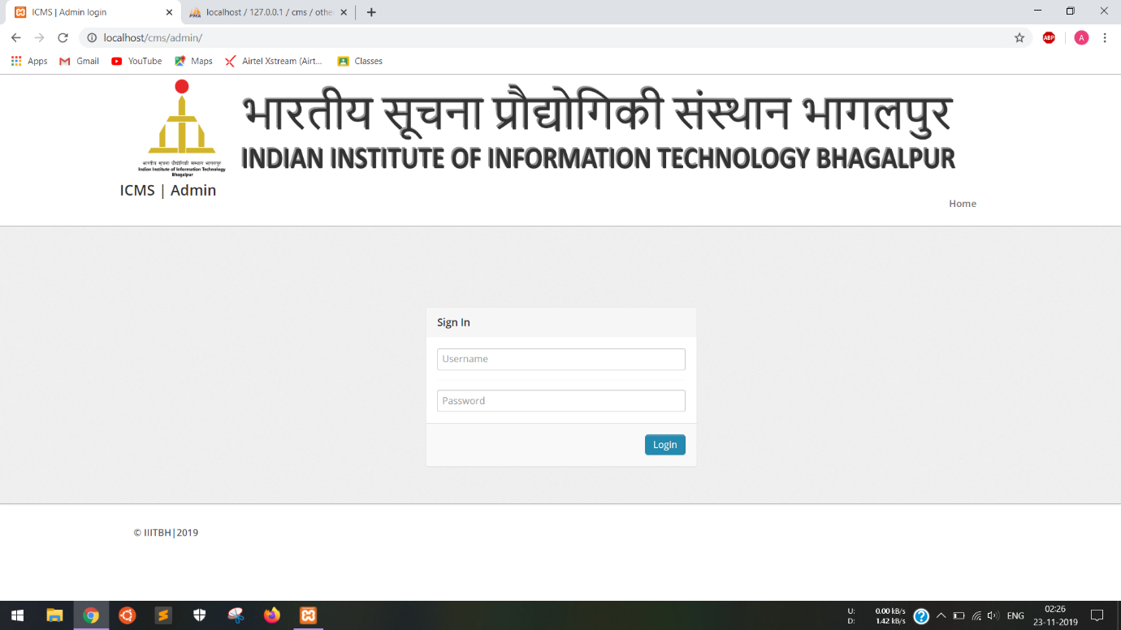

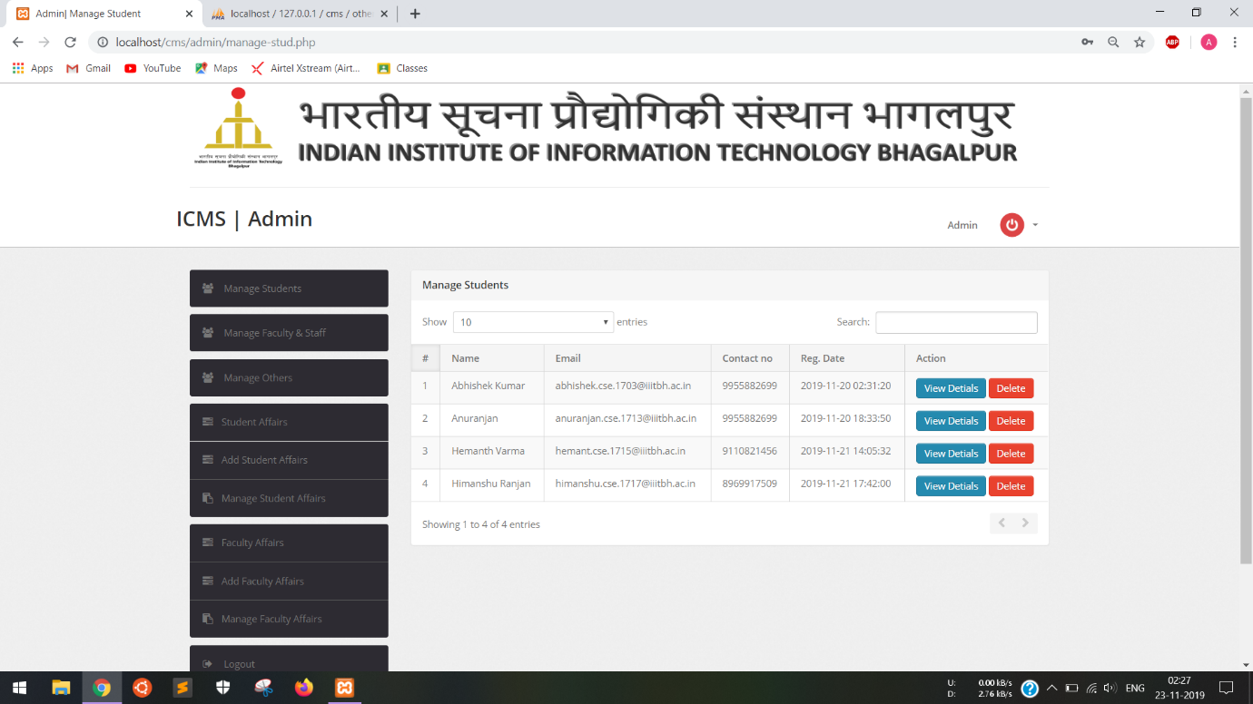

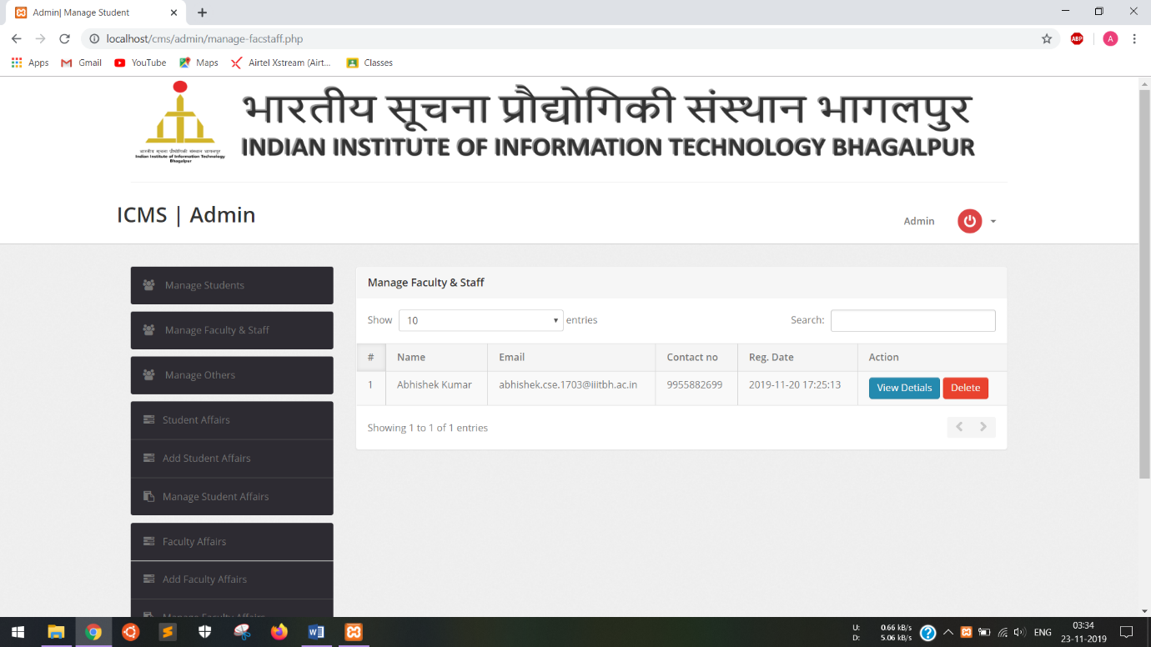

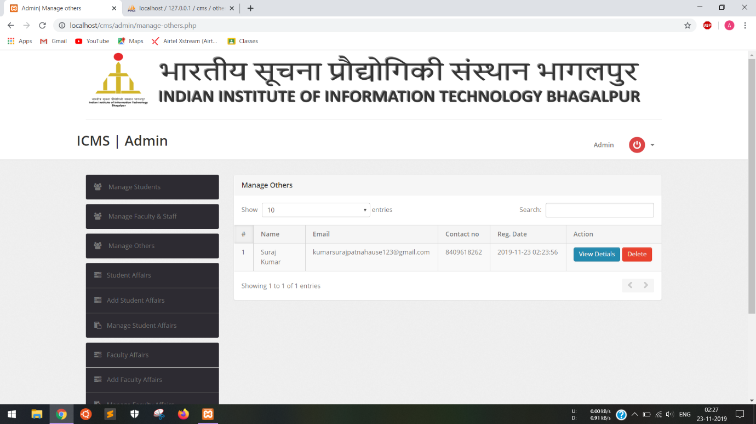

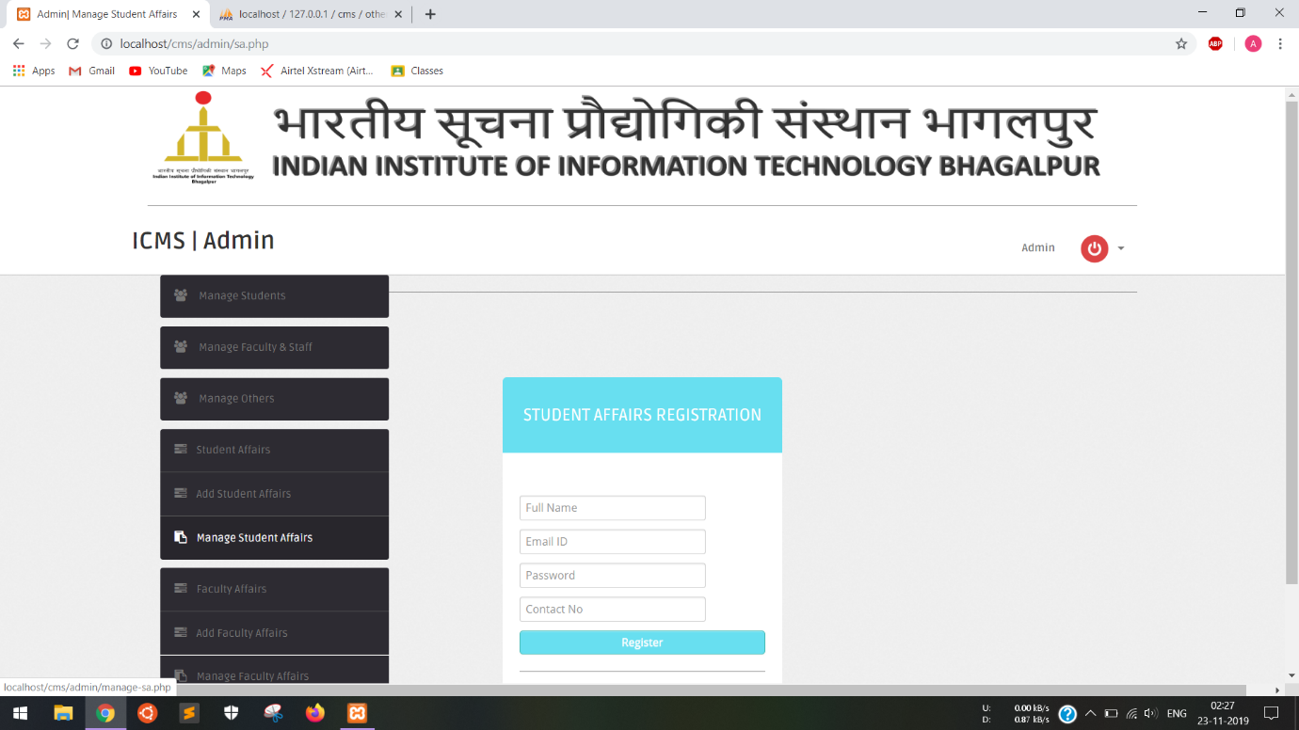

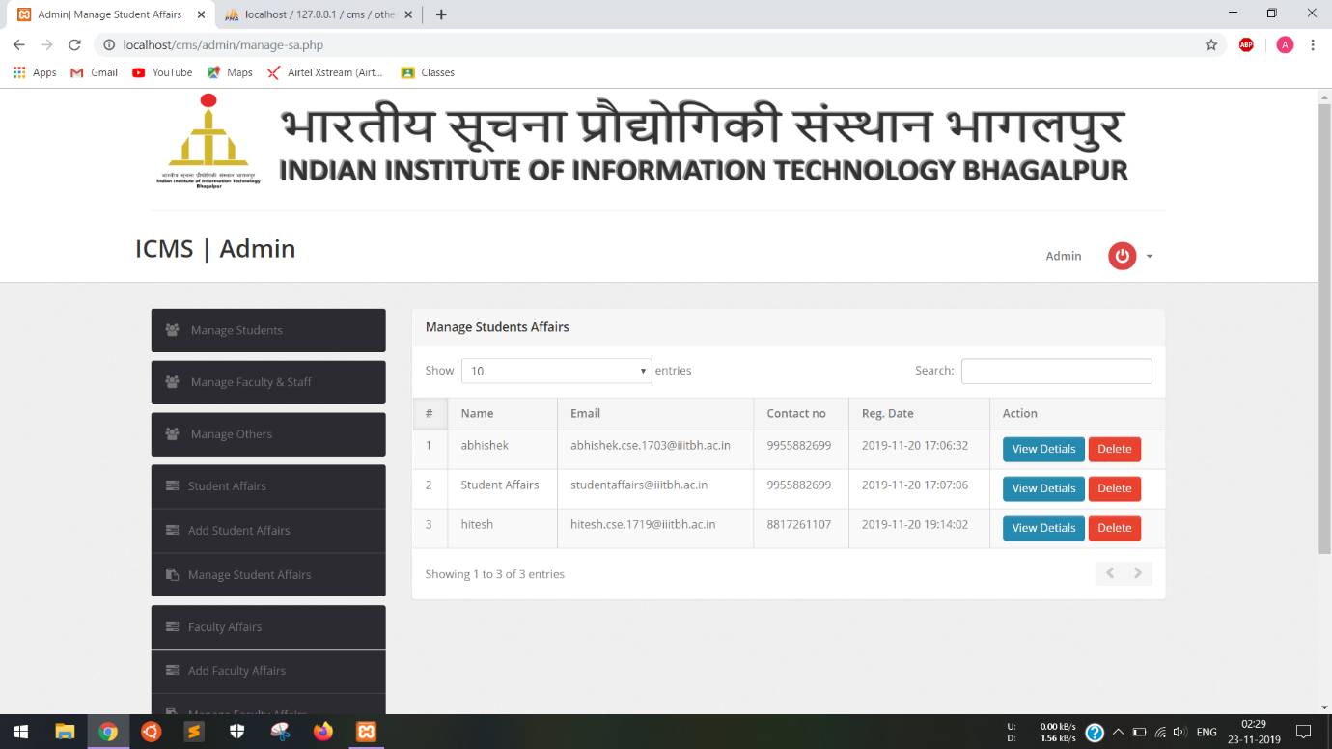

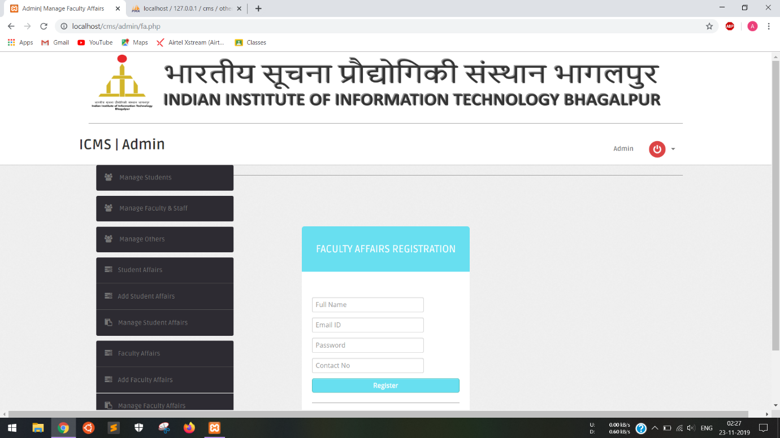

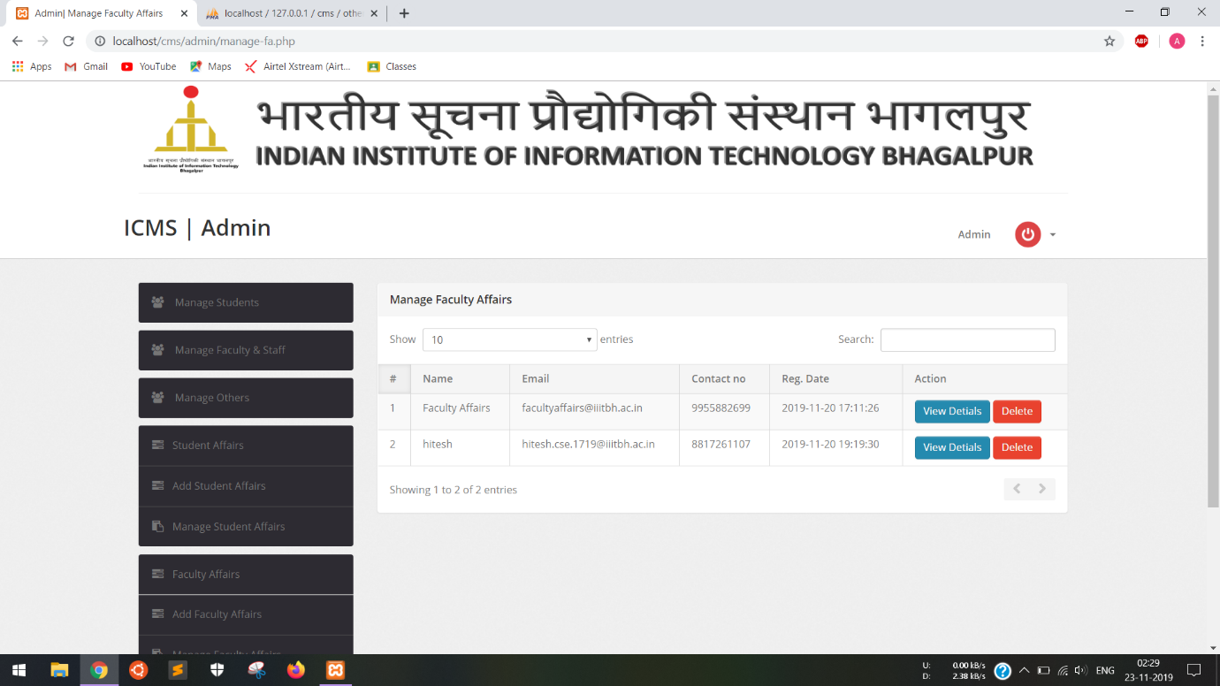

### 4.2.3 Student

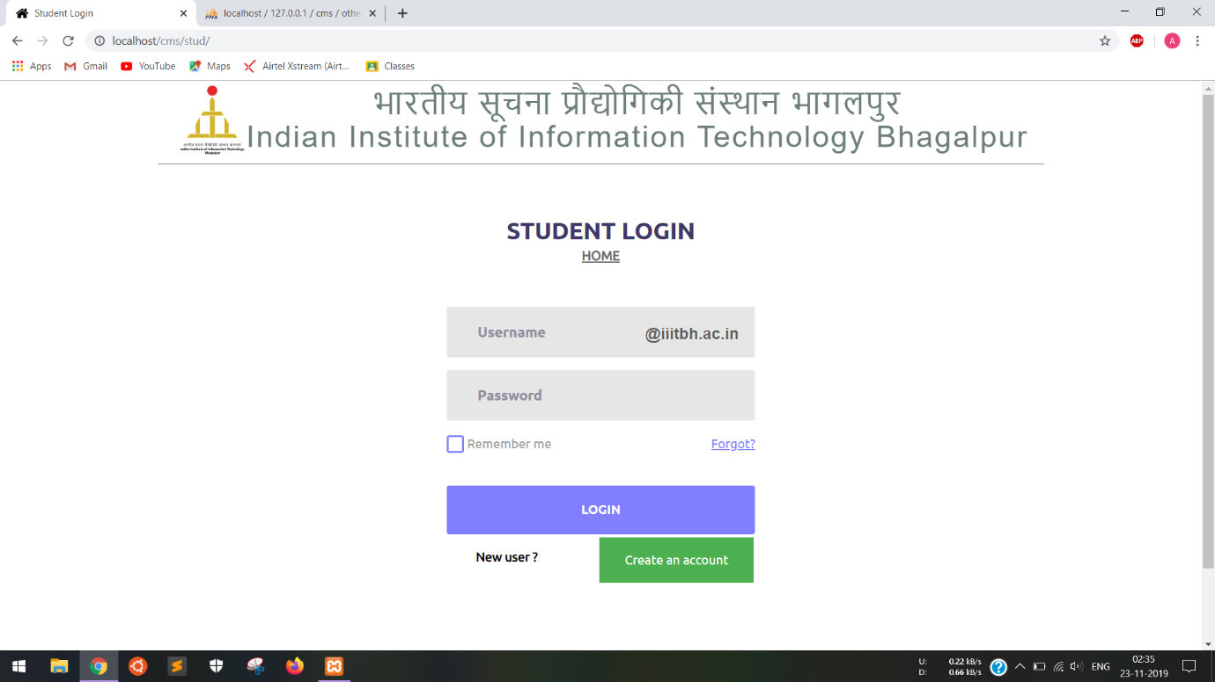

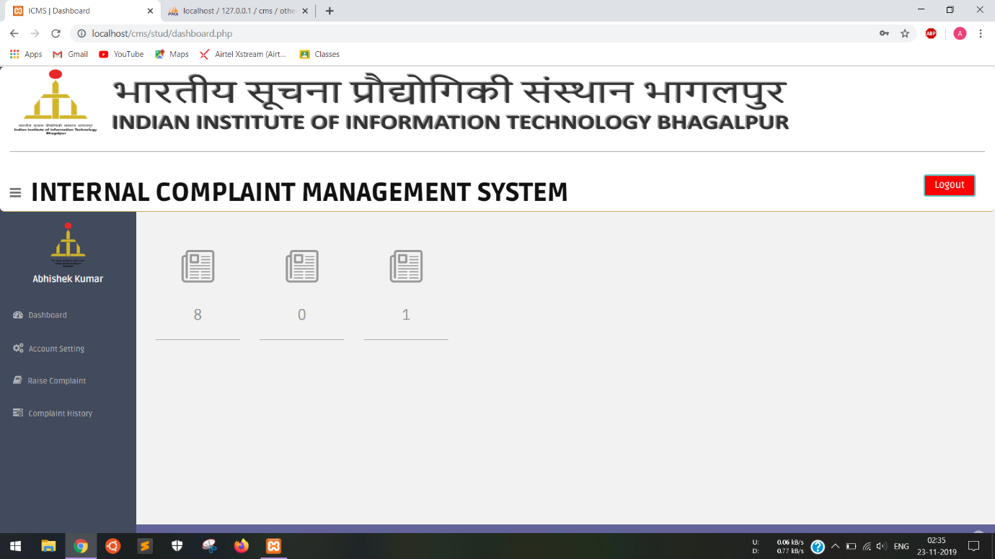

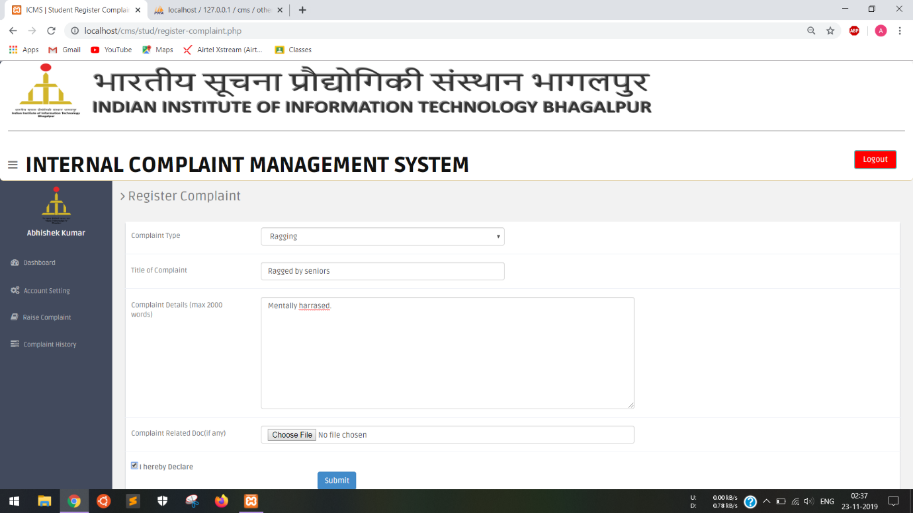

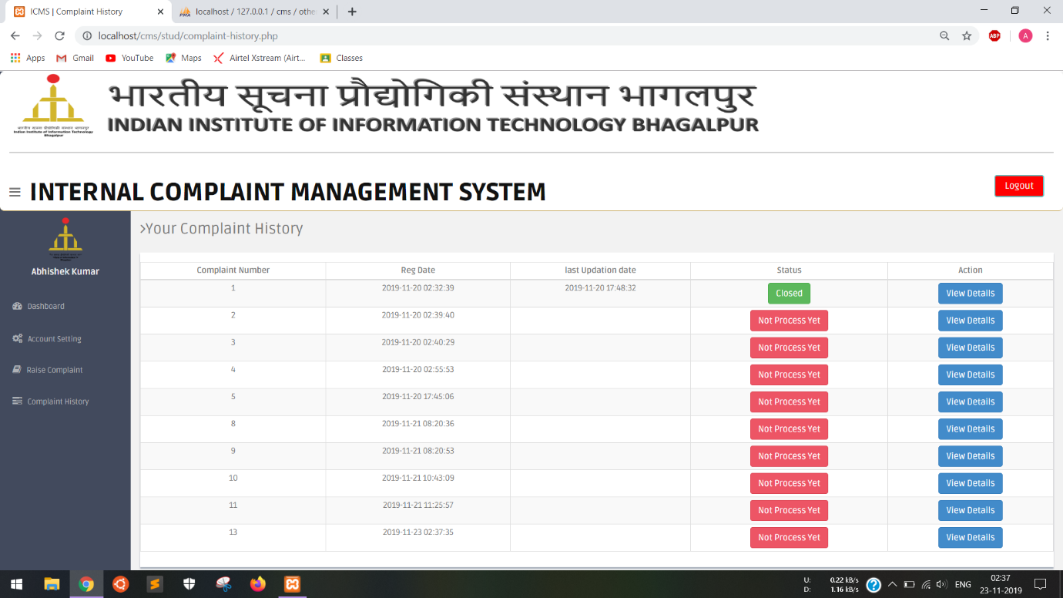

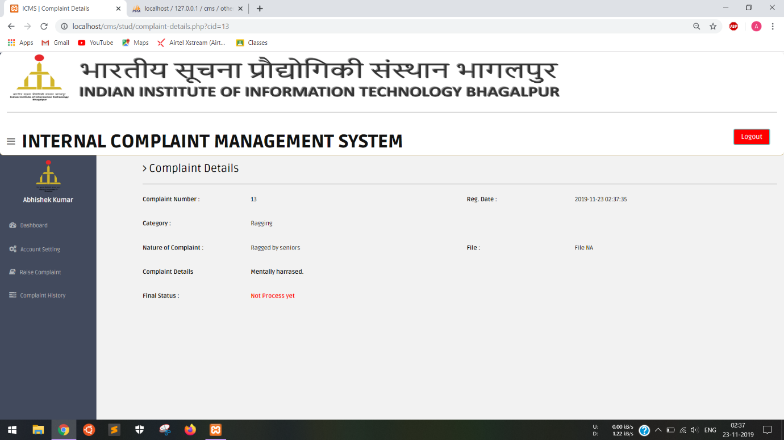

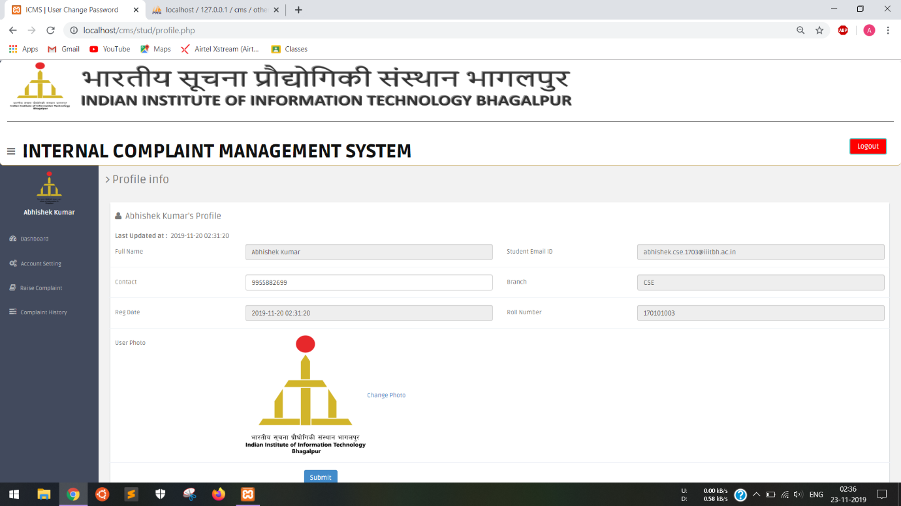

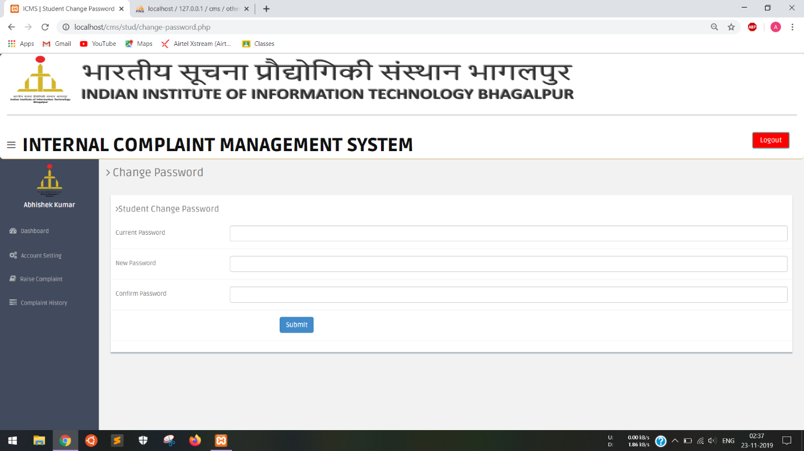

### 4.2.4 Faculty and Staff

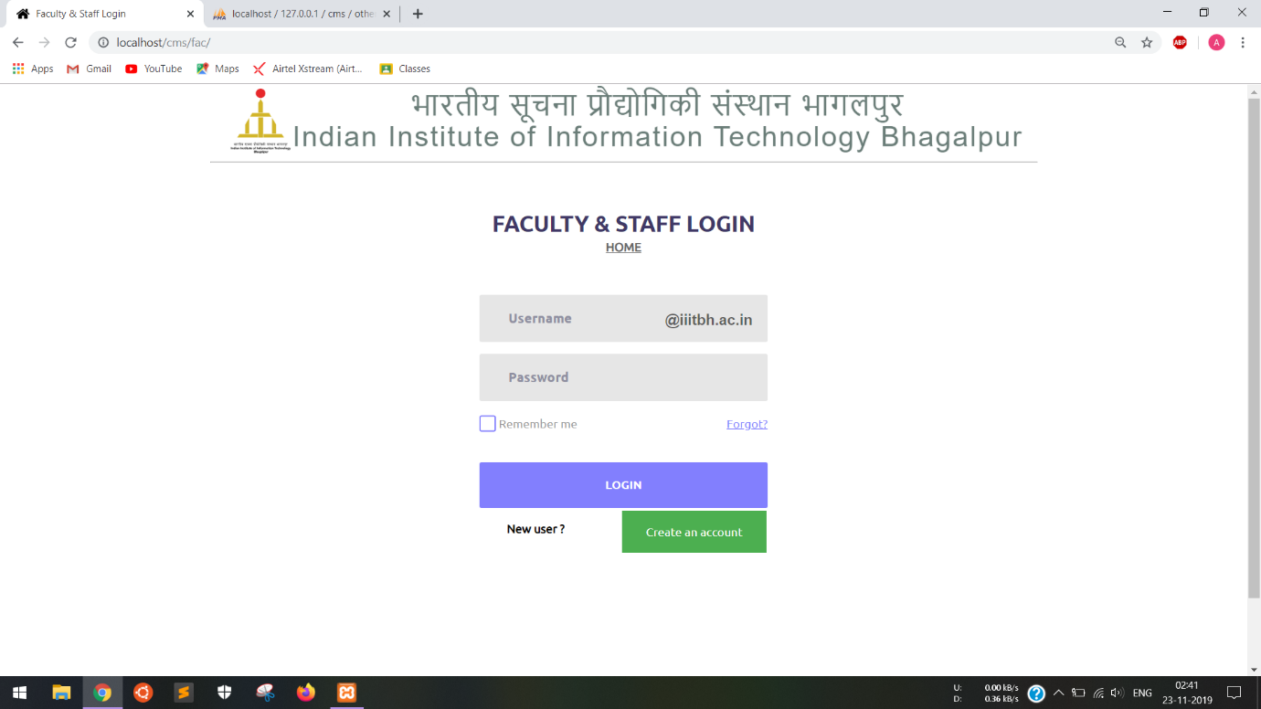

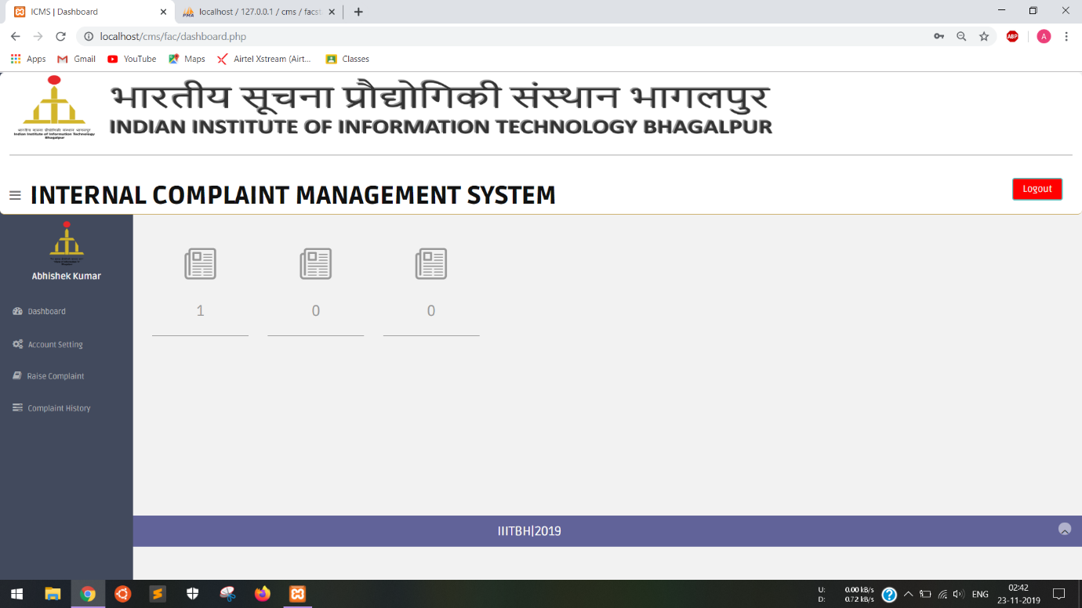

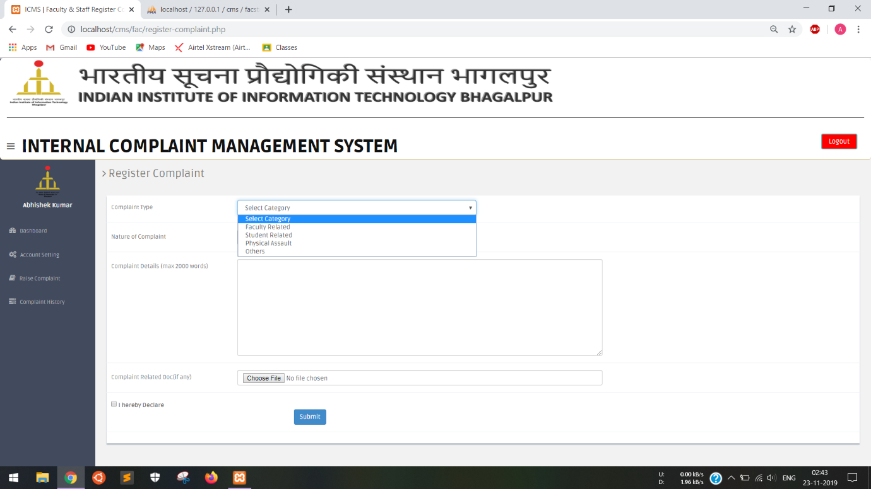

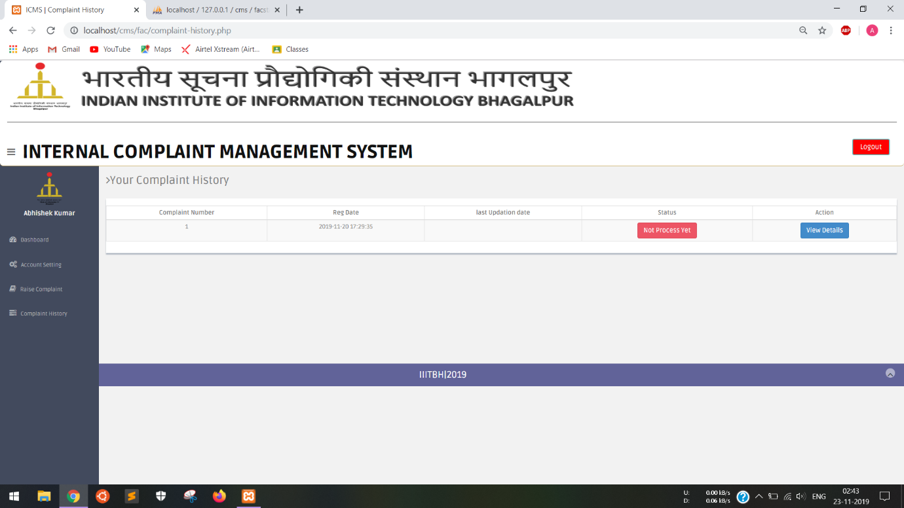

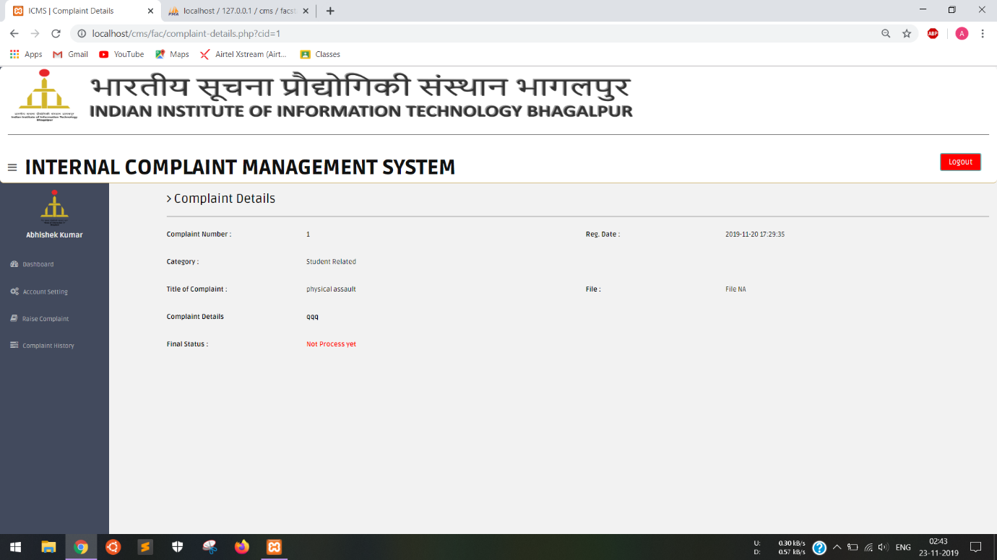

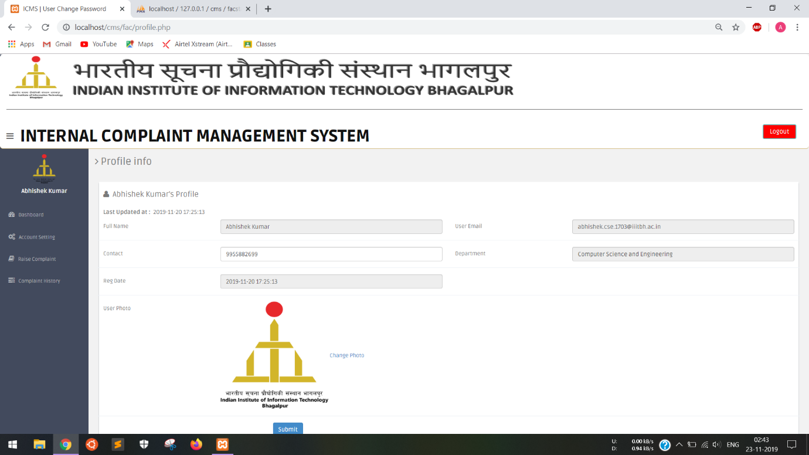

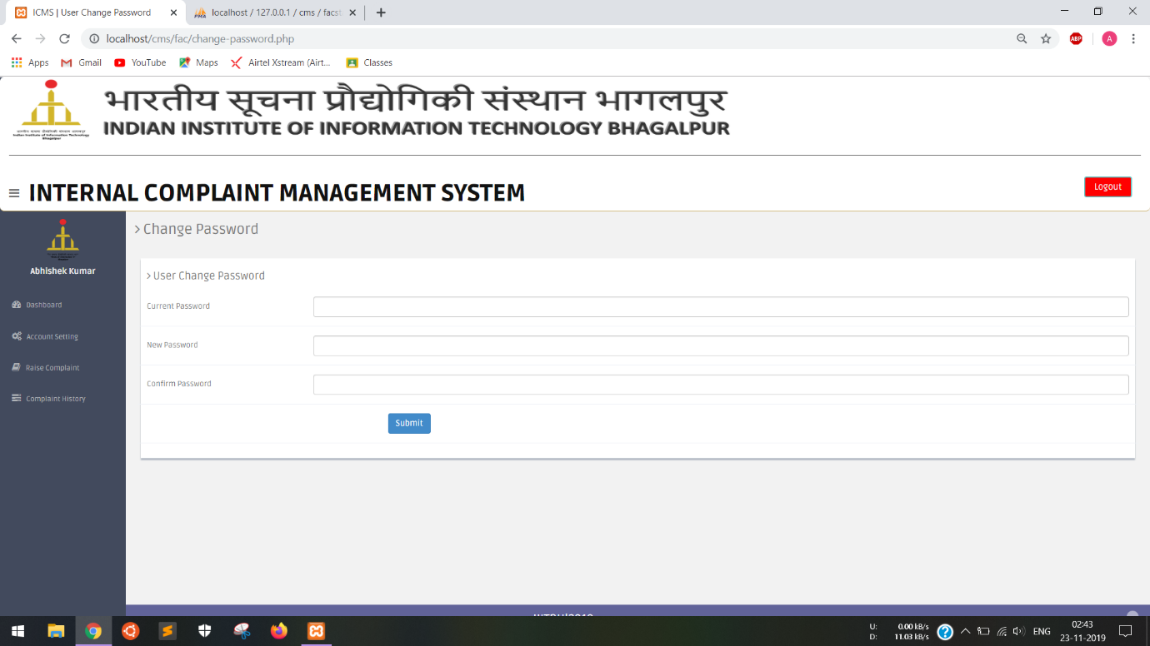

### 4.2.5 Outsider’s

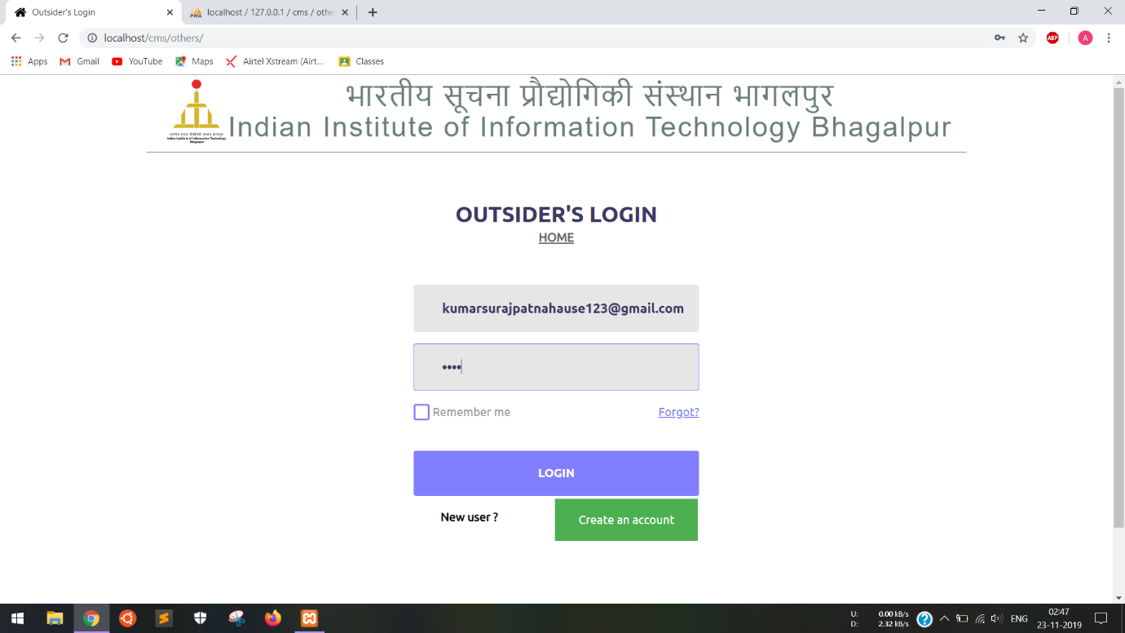

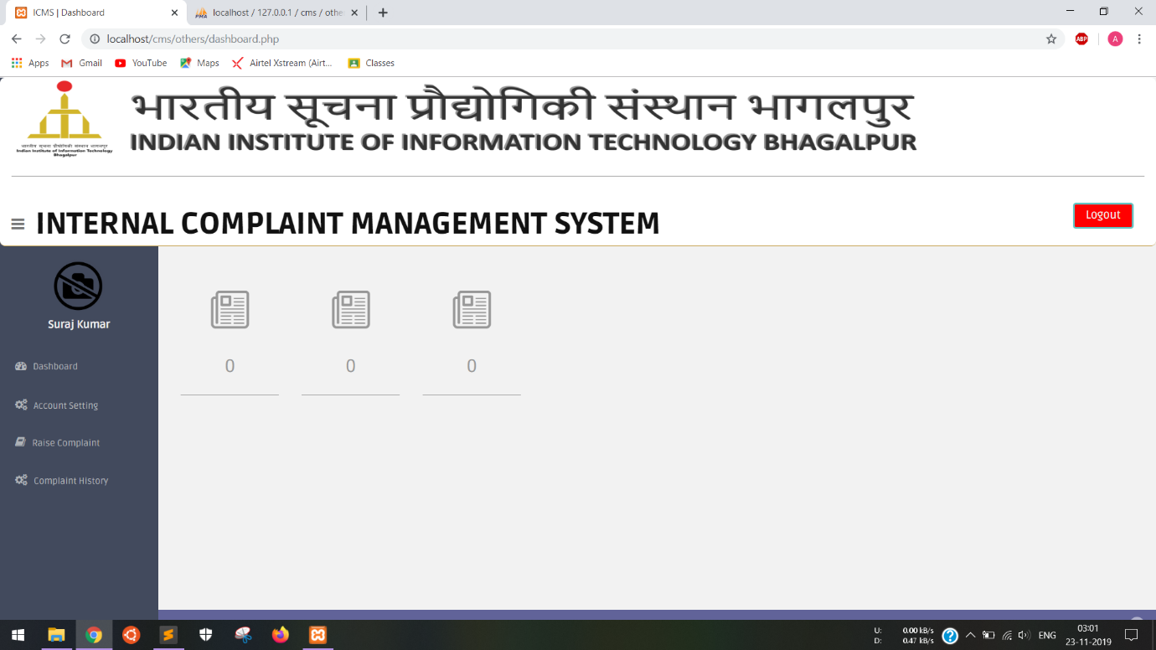

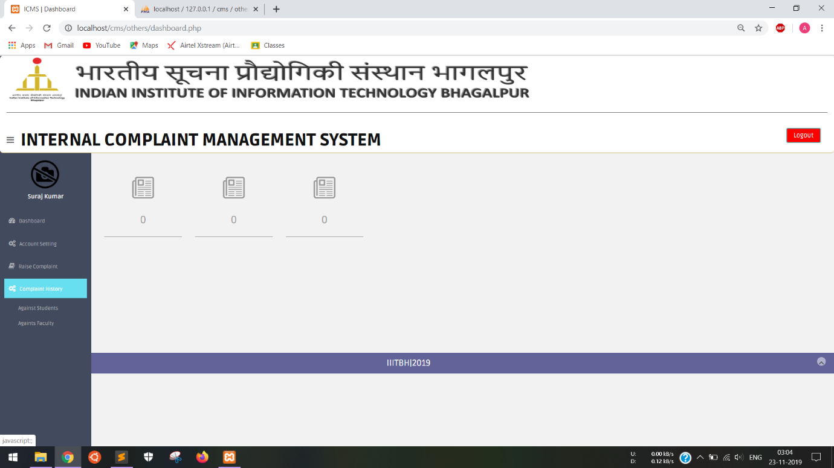

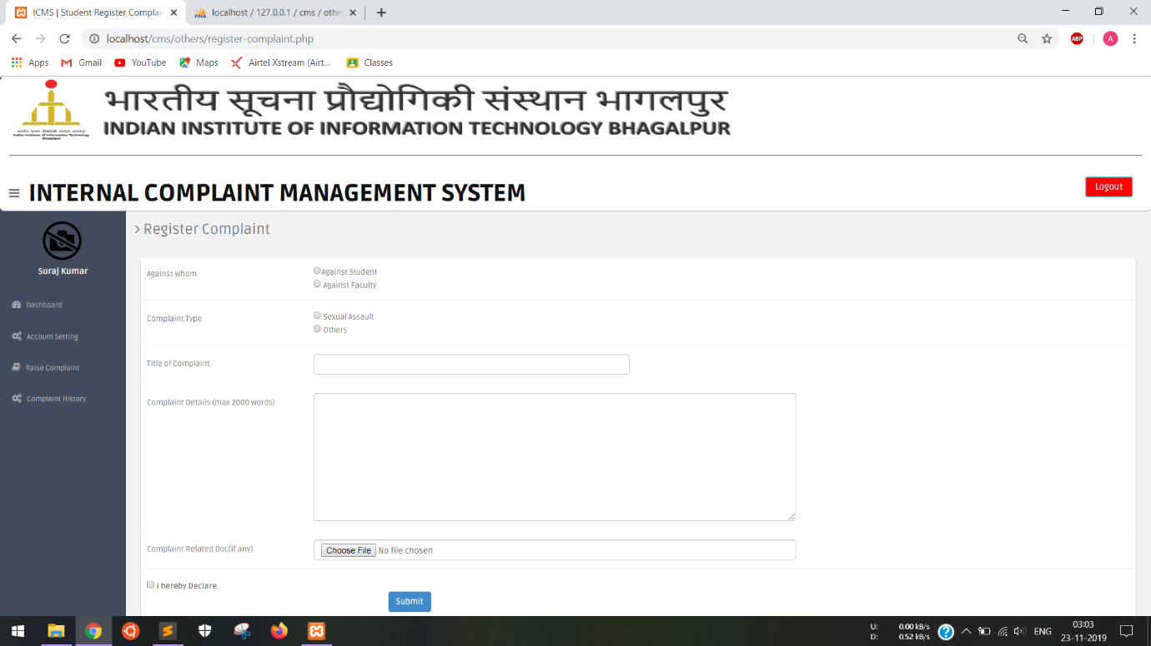

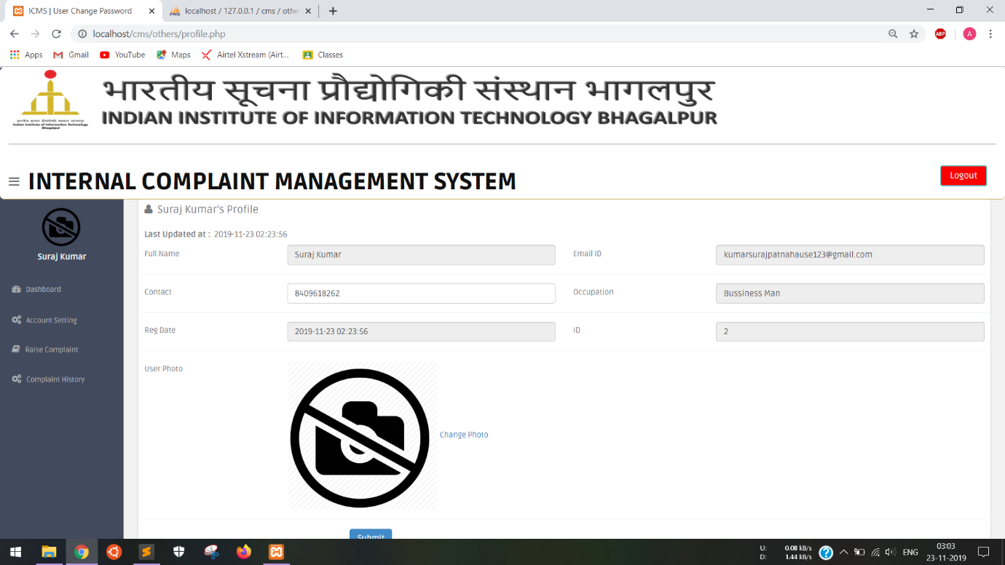

### 4.2.6 Student Affairs Board

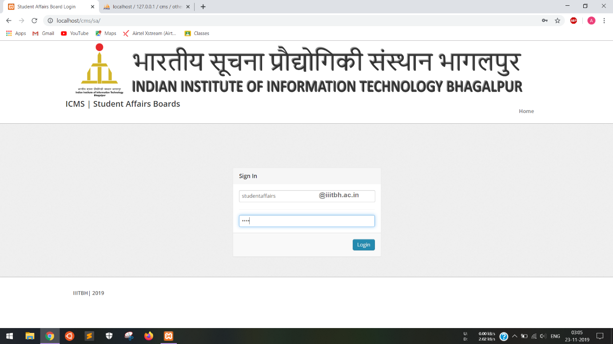

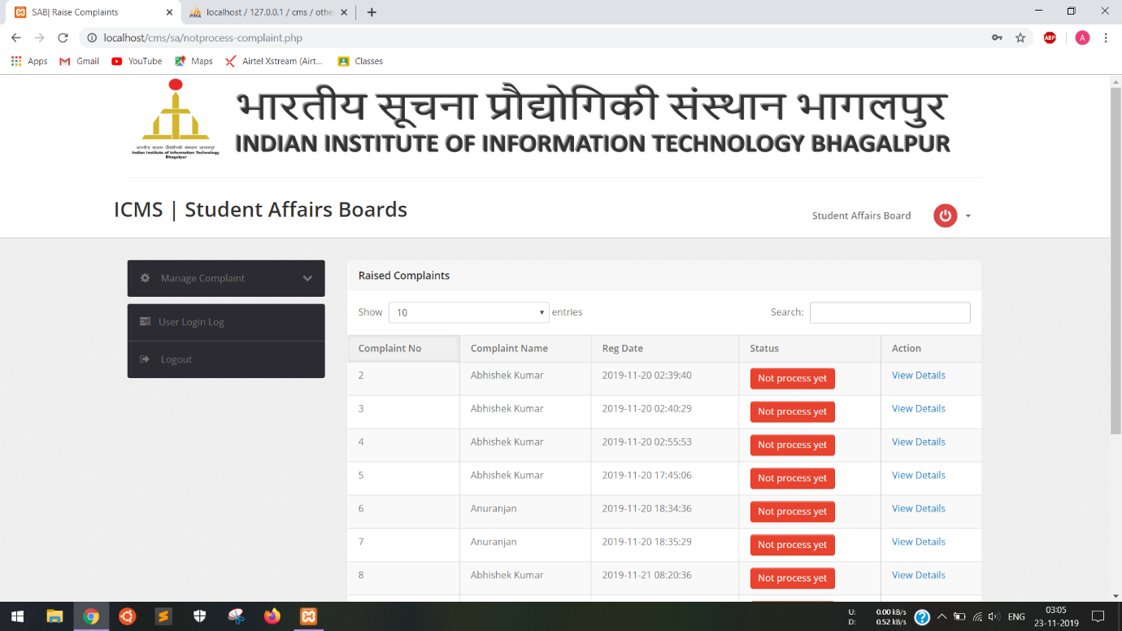

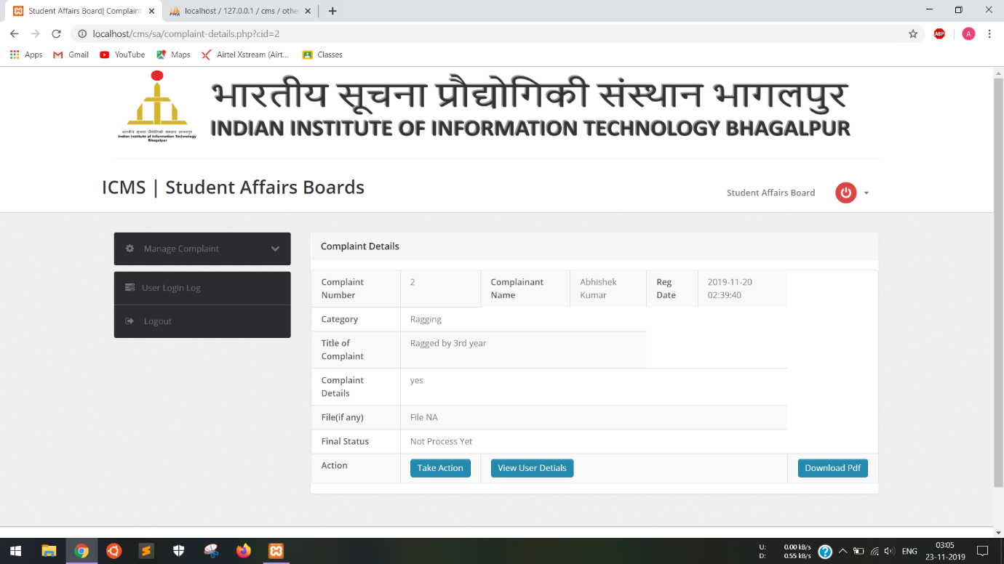

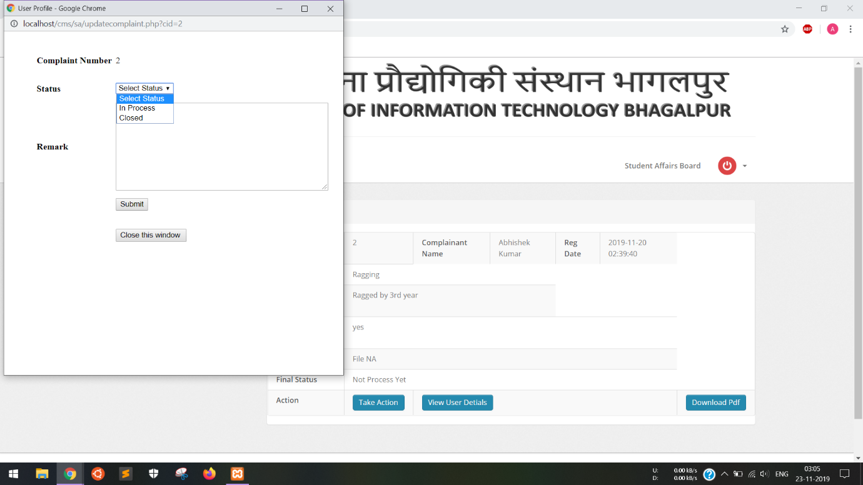

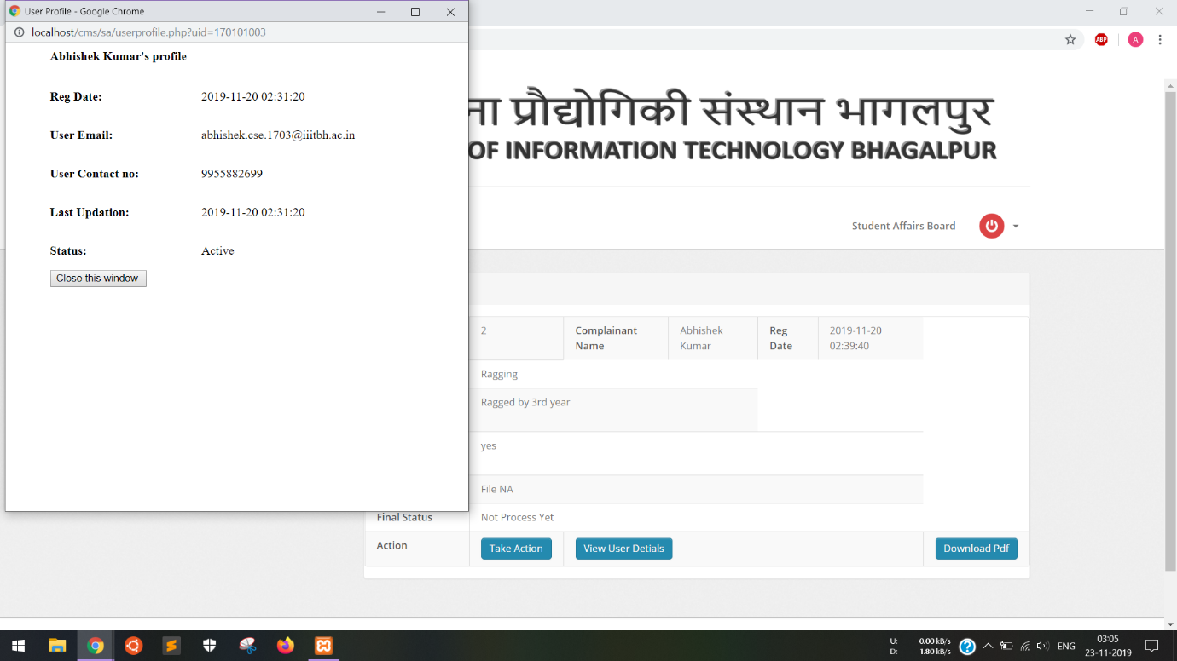

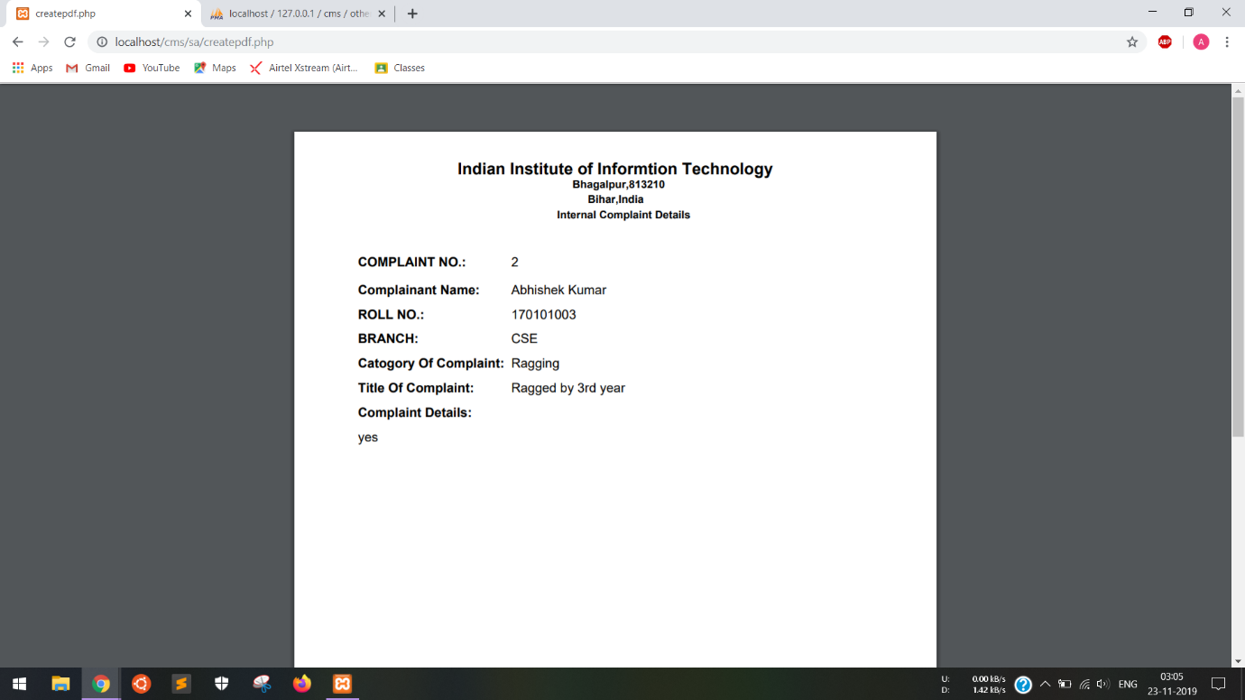

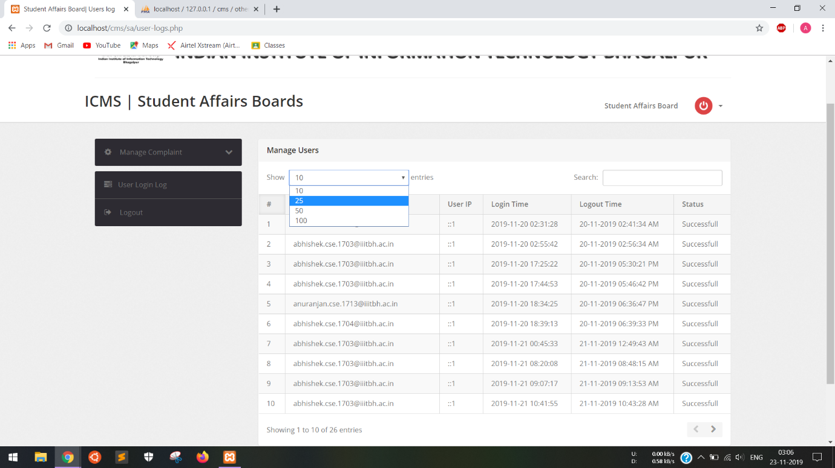

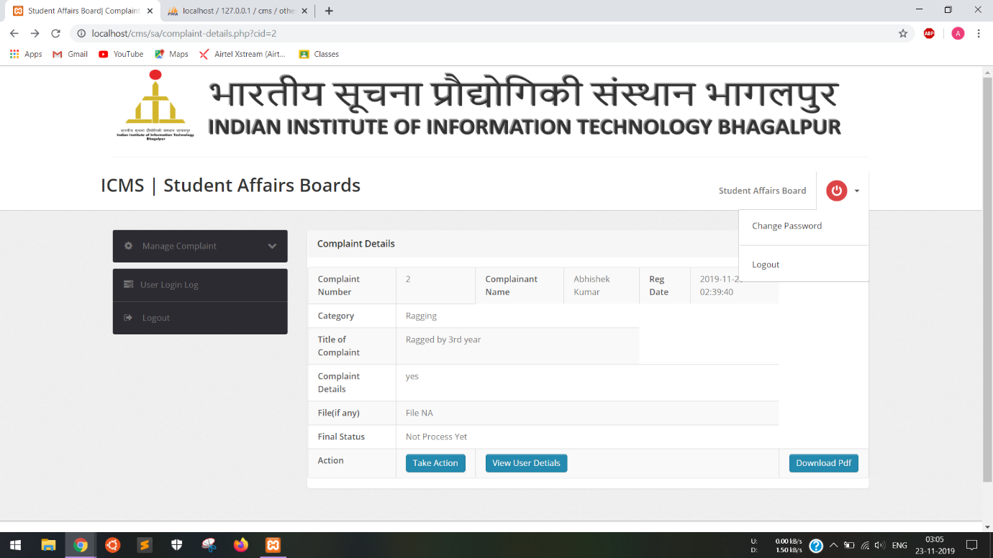

### 4.2.7 Faculty Affairs Board

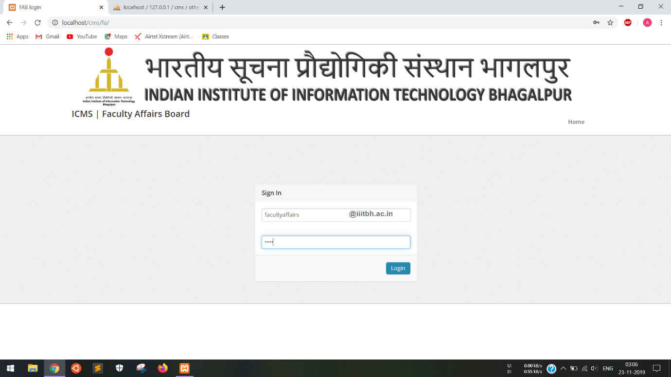

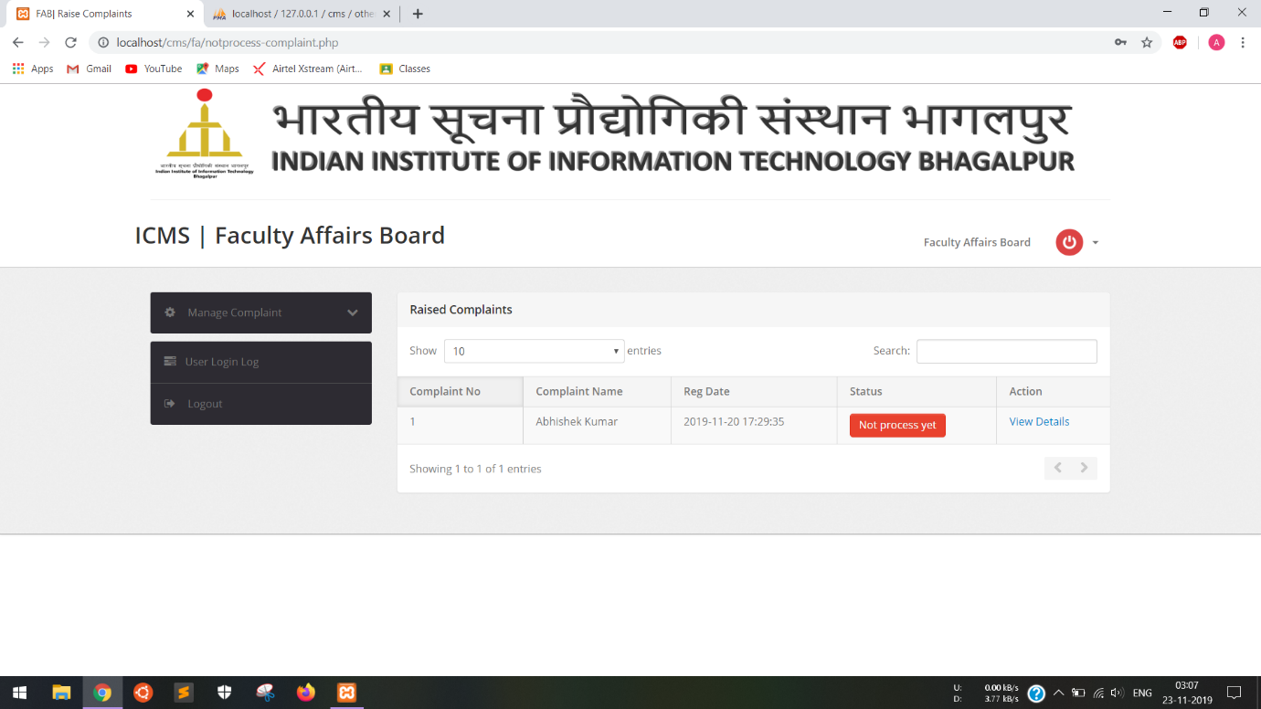

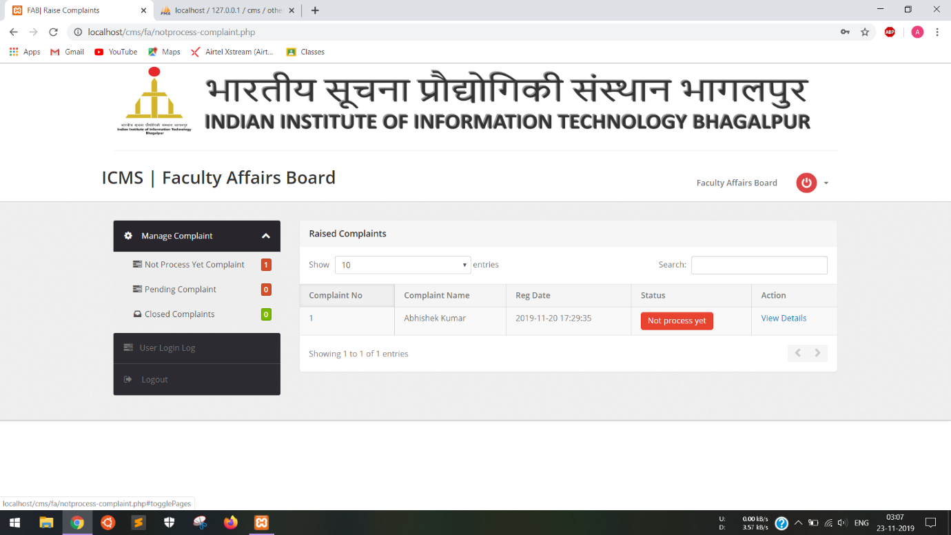

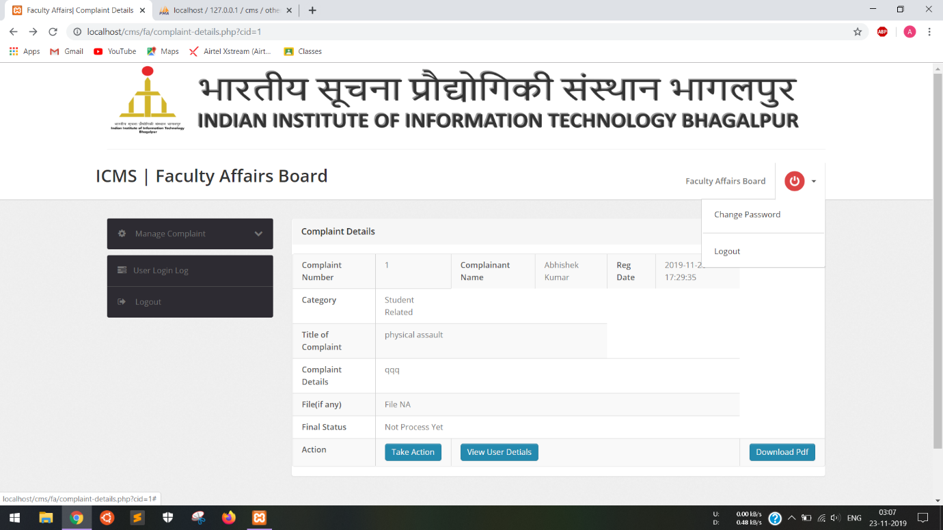

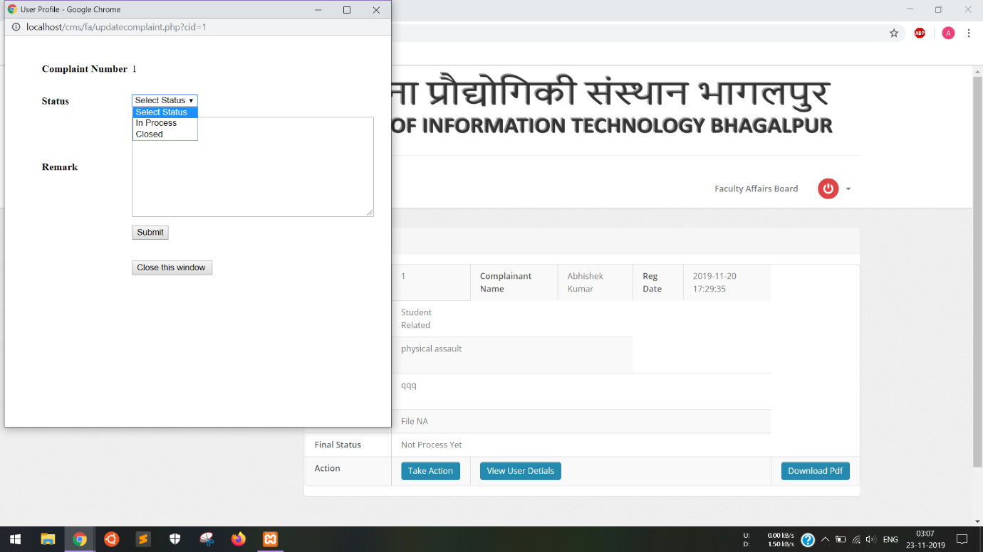

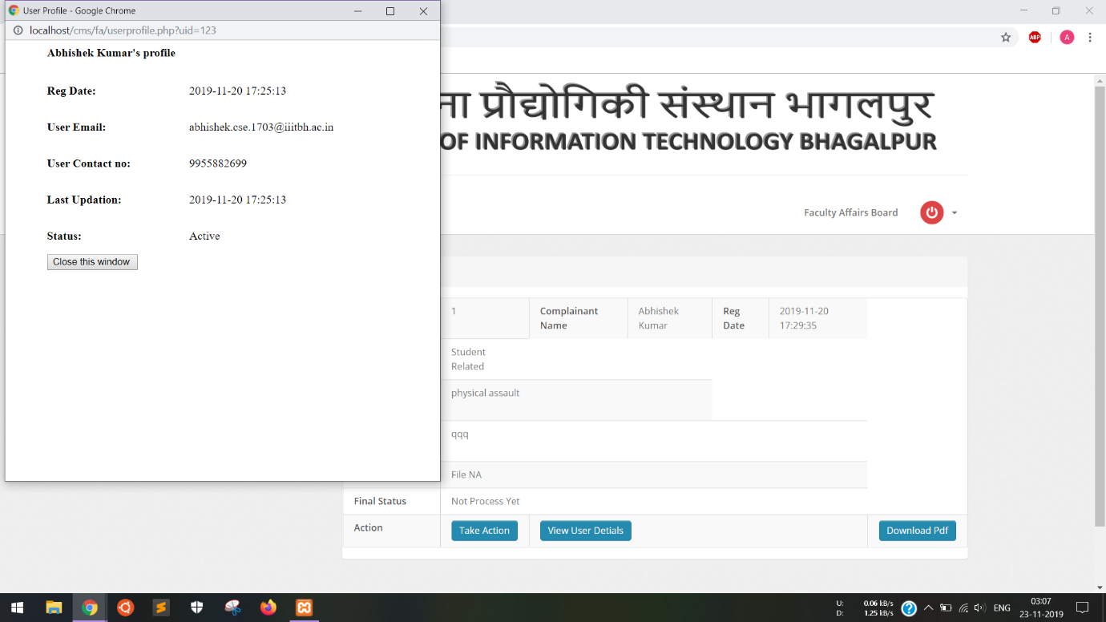

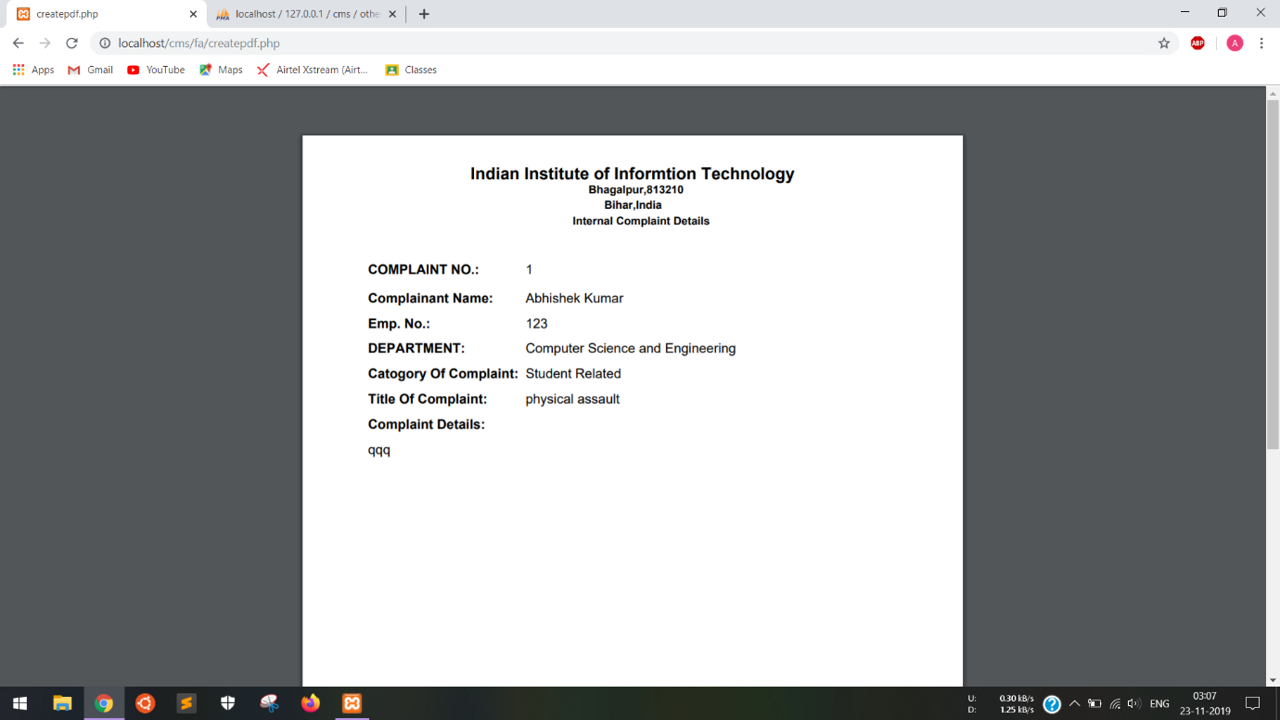

### 4.2.8 Emails

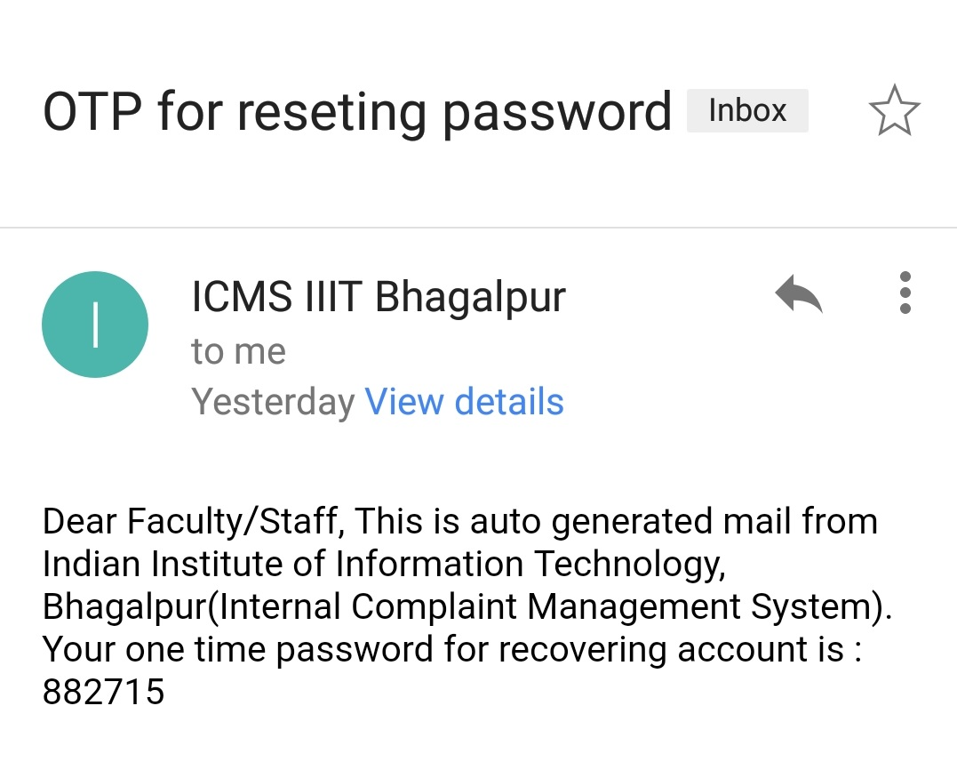

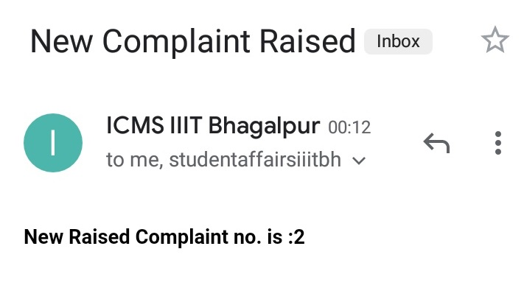

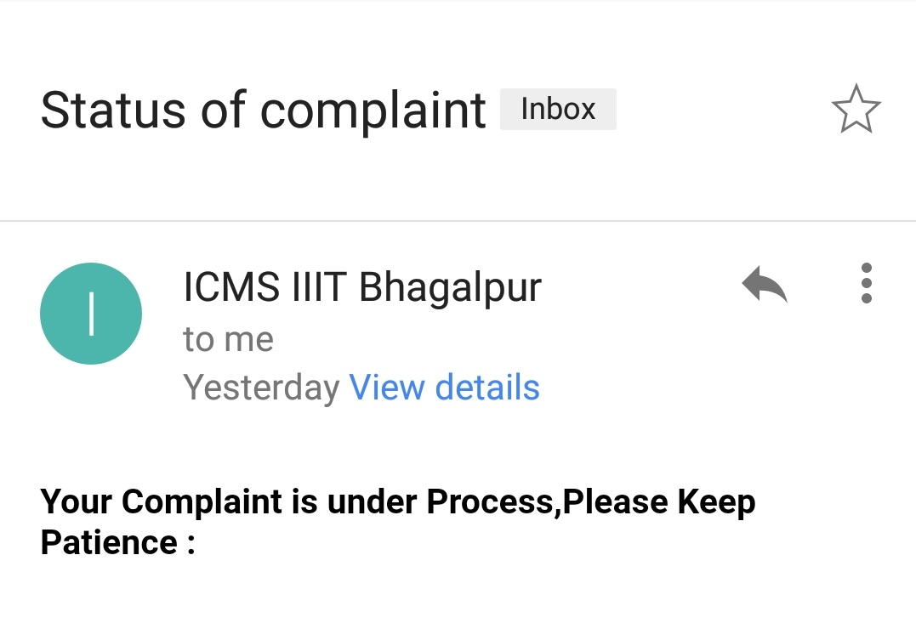

# 5. TESTING

## 5.1 TESTING GOAL

The goal of Employee Leave Management System Testing is to ensure that the system performs as per the functional requirements specified by client. Most cases tested here are done manually per module.

## 5.2 FUNCTIONAL REQUIREMENTS TESTING (BLACK BOX TESTING)

### **5.2.1** Registration for New User

|  |  |  |  |
| --- | --- | --- | --- |
| **Description** : This test will ensure registration of new user | | | |
| **Data Requirements** : Connectivity to database | | | |
| **Steps #** | **Step Description** | **Expected Results** | **Remarks** |
| 1 | Open sign Up page | Sign Up page opens | Pass |
| 2 | Enter Email and Generate OTP | OTP sent through mail | Pass |
| 3 | Enter OTP and click on Submit | Registration form will open | Pass |
| 4 | Fill Registration Form  And Click on register | All required information  entered properly, no error encountered and registration successfull | Pass |
| 5 | Login using credential entered on Sign Up page | Successfully Logged in | Pass |

### **5.2.2** Raised Complaint by Student / Faculty/ Staff/ Outsider

|  |  |  |  |
| --- | --- | --- | --- |
| **Description** : This test will ensure that complaint raised successfully | | | |
| **Data Requirements** : Connectivity to complaint Database | | | |
| **Steps #** | **Step Description** | **Expected Results** | **Remarks** |
| 1 | Sign In using username and password | Dashboard of Student which shows no. of complaint raised | Pass |
| 2 | If no complaint raised earlier, click on Raise Complaint | Raise Complaint form opens | Pass |
| 3 | Form filled and uploaded supported document | Document uploaded successfully | Pass |
| 4 | Submit form | Email send to the respective Complainant and respective board with complaint number | Pass |

### **5.2.3** Processing Complaint by Student Affairs Board / Faculty Affairs Board

|  |  |  |  |
| --- | --- | --- | --- |
| **Description** : This test will check if complaint can be successfully processed | | | |
| **Data Requirements** : Connectivity to complaint Database | | | |
| **Steps #** | **Step Description** | **Expected Results** | **Remarks** |
| 1 | Sign In using respective username and password | Not processed complaint list will open | Pass |
| 2 | Click on view details | Here Take Action, Generate PDF and view users detail could be done | Pass |
| 3 | Click on Take Action | Update status of complaint with remark and email will be sent to complainant with proper detail. | Pass |
| 4 | Click on View Users Detail | Shows user information | Pass |
| 5 | Click on Generate PDF | Download PDF of that complaint with all details | Pass |

### **5.2.4** Admin Activities

|  |  |  |  |
| --- | --- | --- | --- |
| **Description** : This test will ensure admin’s functionality | | | |
| **Sr No.** | **Input/Action** | **Expected Results** | **Remarks** |
| 1 | Sign In using respective username and password | Not processed complaint list will open | Pass |
| 2 | Manage Student/Faculty/Staff/Outsider’s | View details of user and delete user | Pass |
| 3 | Manage Student Affairs Board/Faculty Affairs Board | Add and Delete users in respective board and email will be sent to user with username and password when new user is created by admin | Pass |
| 4 | Change Password | Can change their password | Pass |

## 5.3 Non- Functional Requirements Testing

### 5.3.1 Stability Testing

Stability testing checks to see if the software can continuously function well in or above an acceptable period. This activity of non-functional software testing is oftentimes referred to as load (or endurance) testing.

### 5.3.2 Usability

Usability testing is needed to check if the user interface is easy to use and understand. This test is used to verify if a user that never use the application can search and read result list within a reasonable time.

### 5.3.3 Security Testing

Security testing is essential for software which processes confidential data and to prevent system intrusion by hackers.

# 6. MAINTAINENCE

The Internal Complaint Management System is developed using PHP, HTML, CSS, JS and MySql. Thus, it provides an easy Maintainability and Optimization.

Software maintenance in software engineering is the modification of a software product after delivery to correct faults, to improve performance or other attributes. Maintenance covers about 60% of the phase in Software Development Life Cycle.

The ICMS is the soul property of Group CS311-170101003-P7 and is developed for the Students, Faculty and Staff of **Indian Institute of Information Technology, Bhagalpur**. The group shall provide regular updates for the maintenance of the Internal Complaint Management System.

The Maintenance of ICMS shall include:

* Error Correction
* Bug Fixes
* Enhancement of Capabilities
* Deletion of Obsolete Capabilities
* Optimization

The ICMS has been developed for simplifying the process of handling internal complaints of the Institute and thus it is not affordable to have bugs in the Application but nonetheless some sneaky bugs may find its way to the users. The users are requested to report the bugs as soon as they encounter it so that it could be fixed in the next update.

# 7. CONCLUSION

The proposed Internal Complaint Management System will make the whole complaint management process efficient. Users will be able to register complaint and see current status all via the use of Intranet.

This will also help the Admins, Student Affairs Board and Faculty Affairs Board as they will be able to approve or reject the complaint on their PCs or laptops with college intranet connection.

Ultimately, this project aims at reducing all the paperwork which must be done while registering for complaints. Moreover, this project will simplify the tedious process of internal complaint management system and make it swift and reliable.